Harry Albert Fowler

Service No: 1920

Rank: Sergeant

Unit: 57th Battalion & 59th Battalion

Harry Fowler was born in Fitzroy, the son of William John Fowler and Mary Ann Dunlop

At the time of his enlistment his address was listed as c/o P.O. Bundoora. He was 24 years and 7 months old and working as a Farmer when he enlisted on 21st February 1916. Harry gave his next of kin, Mr William John Fowler of Bundoora.

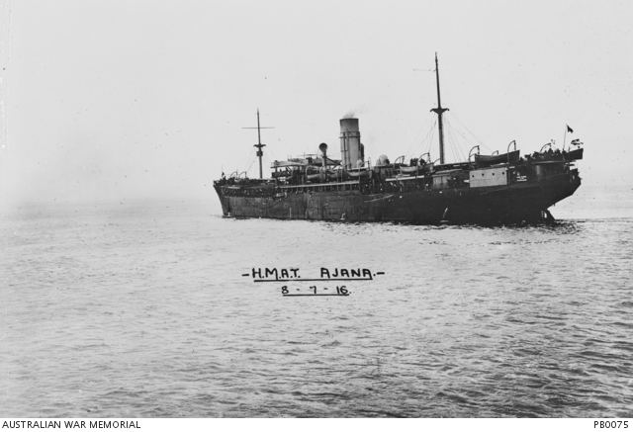After training he embarked on HMAT Ajana A31 on 8th July 1916 and landed in France. He was taken on strength in the 57th Battalion and saw active service on the Western Front in France. Harry was taken on strength of 59th Battalion on 6th December 1916 and promoted from Corporal to Sergeant 14th July 1918.

On 16th September 1917 he was promoted to Lance Corporal. In early November 1917 he was briefly used as a guard over soldiers in hospital and then returned to his unit.

He was promoted to Corporal on 22nd May 1918 and then from Corporal to Sergeant on 14th July 1918.

On 2nd October 1918 he was admitted to hospital with a gunshot wound to his leg.

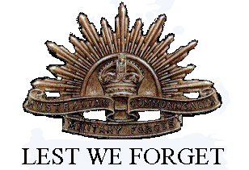He returned to Australia on the City of Exeter on the 27th February 1919. Harry was discharged 19th April 1919.

Harry Albert Fowler received the British War Medal and the Victory Medal. Harry is commemorated on the Greensborough State School Honour Board

Sadly Harry passed away in 1974 and his wife Elizabeth in 1994.