Alfred Gee
Serial No. 1089
Rank: Private
Unit: 5th Battalion
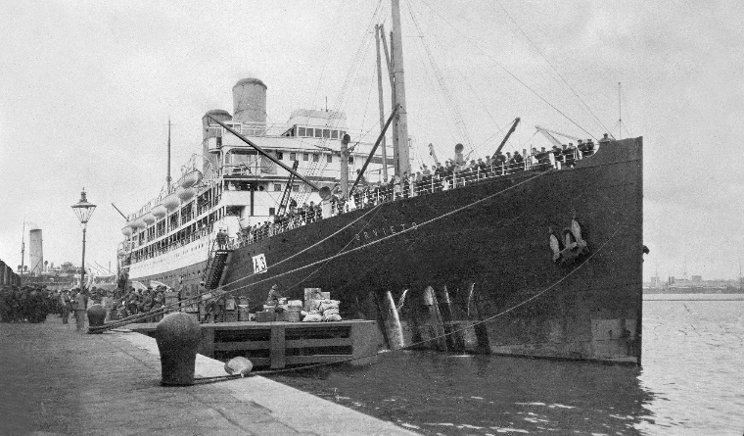
Alfred Gee was born in London in 1892, the son of William Gee. At the time of his enlistment in Melbourne his family was living in London. He appears to have migrated to Australia in 1913.

He was 22 years old and working as a labourer when he enlisted on 15th October 1914. He embarked on 21st October 1914 on HMAT Orvietto A3 and landed in the Dardanelles.

Alf was wounded in the shoulder and both legs during the ANZAC landing on 25th April 1915. After treatment, Alfred rejoined his unit on 31st July 1915. Later in the year he was hospitalised three times to Mudros and Lemnos with gastro and dysentery before being sent to England for treatment.
It was during this time in England that Alfred married Nellie Batt in October 1915.
Alfred returned to his unit in Weymouth England in February 1916 and by April was in the Tel-el-Kebir training camp in Egypt. By May he had joined the British Expeditionary Force in Marseilles. He rejoined his battalion in France in June 1916 and was wounded on 25th July (gunshot wound to foot) and returned to England shortly after. By September 1917, Alfred was deemed a Class B1A3 - Fit for overseas training camp in two to three weeks. He was moved to Sutton Veny for training in October and once again proceeded to France in May 1918. He returned to England on 13th August 1918 and granted ‘1914 Leave’.
Alfred was returned to Australia in October 1918 and soon after applied to the Department of Repatriation for ‘free passage’ for his wife to join him in Australia.
Alfred Gee was awarded the 1914/15 Star, British War Medal and Victory Medal.
A letter from Alfred Gee to the Officer in Charge, Central Army Records, tells of his war experience: “I left Australia October 1914, took part in the Anzac landing 25 April 1915 where I was wounded in both thighs. I returned to Anzac in July and was put out of action again at Lone Pine in August and rejoining my unit in early 1916, wounded again at Pozieres, rejoining 1917. Served to August 1918 and returned on Anzac leave September 1918, discharged December 1918... I now live in Montmorency Victoria. I am 75 years old.”
Alfred Gee was a founding member of the Greensborough RSL “The first recorded history of a meeting involving WW1 veterans was at the house of Alex Spence in Briar Hill in 1929. Those known to attend were Alex Spence, Reg Riglar, Gus Lines, Reg Jackson, Alf Gee, Vic Coe, Frank Gibb, Jack Andrews and without doubt, others who are not known.” (Greensborough RSL website)
