Percy Francis Gibb

Serial No. 1718

Rank: Corporal

Unit: 23rd and 22nd Battalions

Percy Francis (Frank) Gibb was born in 1893 in Richmond, the son of William Gibb and Helena Doyle. According to the “Digger” database, he was registered as Francis Percy Gibb, but enlisted as Percy Francis Gibb.

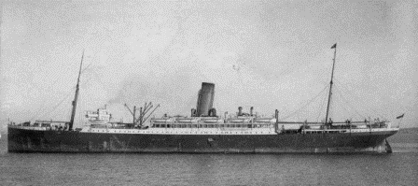At the time of his enlistment the family was living at Richmond. He was 22 years old and working as a builder’s labourer when he enlisted on 20th May 1915. His attestation papers indicate that he had been an apprentice bootmaker for 14 months prior to enlisting.

After training, he travelled on HMAT Demosthenes A64 and landed in Mudros where he was taken on strength 22nd Battalion in Gallipoli (August 1915). He later proceeded to France where he was taken on strength in March 1916.

Frank was promoted to Corporal in August 1917 and mentioned in Sir Douglas Haig’s dispatch of 16th May 1919.

Frank Gibb was returned to Australia in May 1919. Immediately post-war Frank was living in Richmond with his wife, and appears on Richmond electoral rolls (as Percy Francis Gibb) for several decades.

Percy Francis Gibb was awarded the 1914/15 Star, British War Medal and Victory Medal.

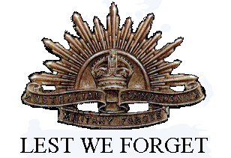Percy Francis (Frank) Gibb was a founding member of the Greensborough RSL “The first recorded history of a meeting involving WW1 veterans was at the house of Alex Spence in Briar Hill in 1929. Those known to attend were Alex Spence, Reg Riglar, Gus Lines, Reg Jackson, Alf Gee, Vic Coe, Frank Gibb, Jack Andrews and without doubt, others who are not known.” (Greensborough RSL website)