James George Gosstray
Service No. 2658
Rank: Private
Unit: 58th Battalion
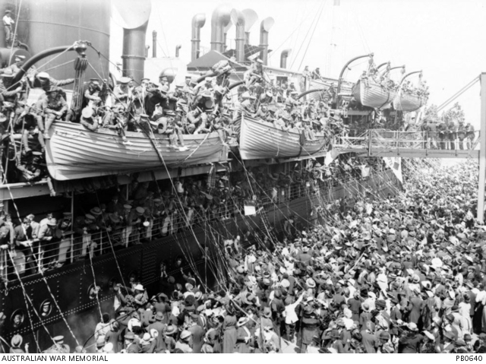
James George Gosstray was born in Collingwood in 1895, the son of Benjamin Gosstray and Mary Chinnock. At the time of his enlistment the family was living at Diamond Creek. He was 21 years old and working as a farm hand when he enlisted on 21st June 1916.

After training in Broadmeadows he embarked on HMAT Nestor A71 and landed in Plymouth England.
He was taken on strength 7th February 1917 and saw active service in France.

James was treated for scabies in field hospitals from 3rd to 11th March 1917 then admitted to hospital in London suffering trench foot on 18th March. When recovered, James was classified “A3” – fit for overseas training camp to be ‘hardened’ prior to joining his unit overseas. On 1st July he was sent to the Overseas Training Depot at Perham Downs for two weeks. He returned to his unit at the end of August.
James Gosstray died of wounds received in action on 27th September 1917 at Polygon Wood, Belgium. He is buried at Tyne Cot British Cemetery Passchendale, Belgium.
He was awarded the British War Medal, Victory Medal and Memorial Plaque.
