Henry Green
Serial No.: 722
Rank: Private
Unit: 14th and 39th Battalions
Henry Green was born in Footscray in 1889, the son of Alfred Green. At the time of his enlistment the family was living at Grace Park Greensborough. He was 27 years old and working as a fitter when he enlisted on 19th March 1917.
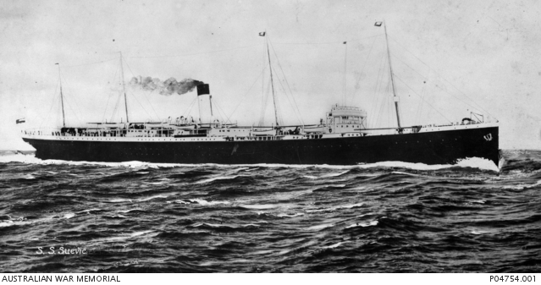
After training in Seymour he travelled on HMAT Suevic A29 and landed in Liverpool in August 1917.
He was taken on strength in the 39th Battalion in December 1917 and saw active service in France.

Henry Green changed his next of kin in July 1918 when his father Alfred Green was an Australian munitions worker in Kent England. His mother was still living in Greensborough.
Henry Green was returned to Australia in March 1919. He was awarded the British War Medal and the Victory Medal.
Henry Green is commemorated in Greensborough on the Greensborough and District Honour Board at the Greensborough RSL.
