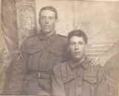
Hubert Vince Guthrie
Hubert and Leslie Guthrie
Serial No. 1357
Rank: Corporal
Unit: 2nd Cyclist Company
Hubert Vince Guthrie was born in Boolara in 1894, the son of William Doon Guthrie and Barbara Louise Morrow. His parents gave written permission for him to join the British Expeditionary Forces. At the time of his enlistment the family was living at Bundoora. He was 20 years old and working as an auctioneer’s clerk when he enlisted on 5th July 1915.
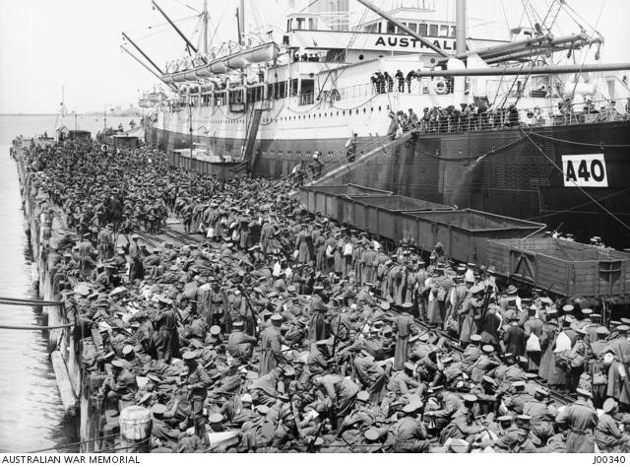
After training in Broadmeadows he travelled on HMAT Ceramic A40. He was taken on strength and saw active service in France.
Hubert was promoted to Corporal in May 1916, attached to the 4th Division Signal Company in September 1917 and to the 1st ANZAC Cyclist Company in November 1917. He was hospitalised twice in 1918 with appendicitis.
Hubert’s brother Leslie Condor Guthrie served with the 22nd Battalion and 1st ANZAC Cyclist Battalion.
Hubert Vince Guthrie was returned to Australia in July 1919 and was awarded the 1914/15 Star, British War Medal and Victory Medal.
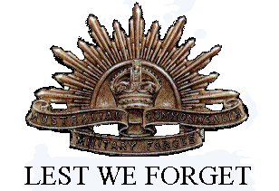
On the 1919 Electoral Roll, Hubert and brother Leslie were living in Bundoora and working as farmers.
Hubert married Una Moss in 1922. They lived in the Strathmerton area until the 1970s. Hubert Guthrie died in Numurkah in 1974.

