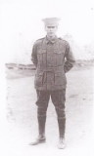
Leslie Condor Guthrie
Serial No. 388
Rank: Private
Unit: 22nd Battalion and 1st ANZAC Cyclist Battalion
Leslie Condor Guthrie was born in Footscray in 1896, the son of William Doon Guthrie and Barbara Louise Morrow. At the time of his enlistment the family was living at Bundoora. He was 18 years old and working as a carpenter when he enlisted on 3rd February 1915.
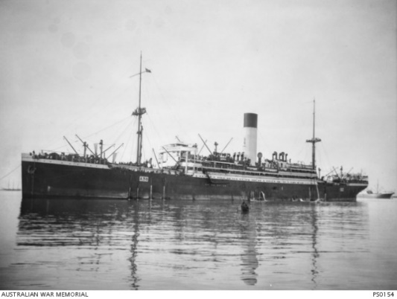
After training he travelled on HMAT Ulysses A38. He was taken on strength and saw active service in France.
Leslie Condor Guthrie was wounded in action (gunshot wound to the scalp) in France in June 1916, sent for treatment in England and joined the 22nd Battalion in October 1916, moving to the 1st ANZAC Cyclist Battalion in December 1916. In August 1917, Les committed the ‘crime’ of “using his cycle without permission” and forfeited one day’s pay as a penalty. In September and December 1917 he was admitted to hospital with colitis.
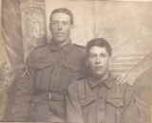
Les’s brother Hubert Vince Guthrie served with the 2nd Cyclist Battalion.
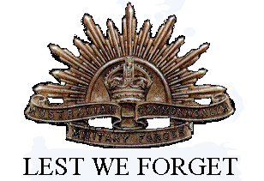
Leslie Condor Guthrie was returned to Australia in June 1919 and received a medical discharge in September 1919. He was awarded the 1914/15 Star, British War Medal and Victory Medal.
Hubert and Leslie Guthrie

Post-war Leslie was working in Beechworth as a labourer (1928 Electoral Roll). He died in December 1977 and is buried at Fawkner Cemetery.

