Roy James Halse
Service No. 51375
Rank: Private
Unit: 24th Battalion & 31st Battalion
Roy James Halse was born in Broken Hill on 4th June 1899, the son of Alfred Halse and Ellen Jane Davey. He lived at 338 Barkly St, Fitzroy and was a munition worker when he enlisted on 25th February 1918. He was 18 years and 8 months old.
At the time of his enlistment his father Alfred was living in Greensborough.
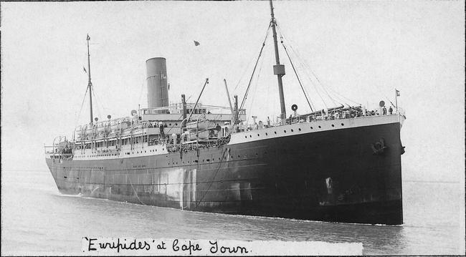
After training he embarked on HMAT Euripedes A14 on 1st May 1918, changed ships in New York and landed in Liverpool on 2nd July 1918. He was taken on strength in the 24th Battalion in France on 24th September 1918 and on 2nd November 1918 was transferred to the 31st Battalion.
On 6th January 1919 was hospitalised with influenza and this developed into bronchial pneumonia. He returned to Australia on the Hospital Transport Leicestershire arriving on 21st June 1919. He received a medical discharge on 23rd July 1919.
Roy Halse received the British War Medal and the Victory Medal.
On 5th November 1933 he married Winifred May Hales.
He served with the 7th Victorian Battalion of the Volunteer Defence Corps in World War 2 between 25th May 1942 and 22nd October 1943. This time he had the rank of Lieutenant and the unit was based at Lismore, Victoria. He was the Postmaster at Timboon at this time.
Roy passed away 1946 at Hampton.
