Rowland Hardley
Service No. 1303
Rank: Sergeant
Unit: 5th Battalion
Rowland Hardley was born in Barnsley, Yorkshire in 1886, the son of Walter Hardley and Mary Broadbent. At the time of his enlistment he was living with his family at Black Diamond, Walhalla. Rowland named his wife Mrs. Jessie Hardley as next of kin. He was 28 years old and working as a miner when he enlisted on 30th October 1914.
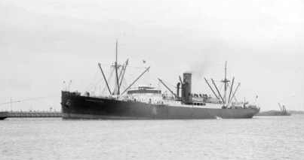
After training he embarked on HMAT Clan McGillivray A46 on 2nd February 1915 and landed in France. He was taken on strength in the 5th Battalion and saw active service on the Western Front in France.
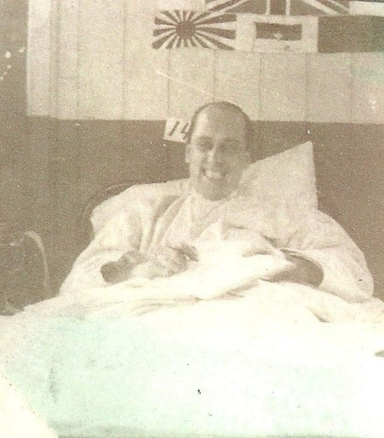
Rowland was posted ill, admitted 24th July 1915 to No. 1 Australian Casualty Clearing Station, Anzac; transferred on 1st August 1915 to 24th Casualty Clearing Station, Mudros; transferred to England, and admitted on 30th August 1915 to King George Hospital, Stamford.
He was invalided to Australia, and returned per “Ascanius”, which reached Melbourne on 30th April 1916, illness being specified as Rheumatism; was discharged on the 25th July 1916.
Roland in hospital 1915
Rowland named his wife Mrs. Jessie Hardley as next of kin.
He received the 1914/1915 Star, British War Medal and the Victory Medal.
He was the Foundation President Greensborough RSL. They lived in Bundoora where he was a Farmer.
Sadly Rowland passed away at Caulfield Repatriation Hospital on the 10th February 1935 and Jessie in 1941.
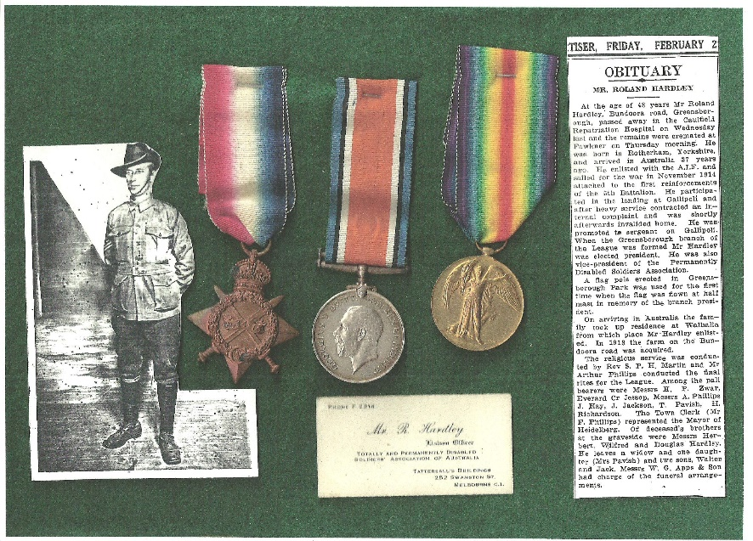

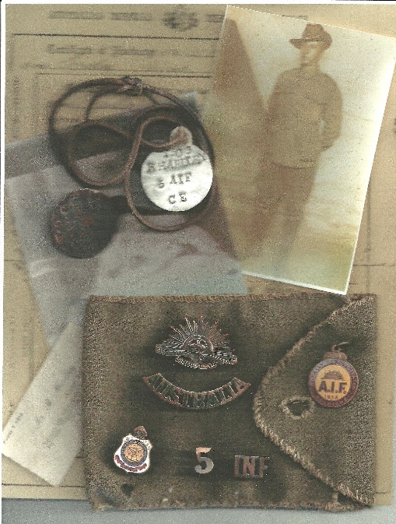

Photographs of Rowland Hardley’s memorabilia and Diary excerpt kindly shared by his family.
