William Howard
Service No. 1564
Rank: Private
Unit: 8th Battalion
William Howard was born in Queenstown (St Andrews), the son of Henry Valentine Howard and Mary Ann Healey in 1890. His mother who was given as his next of kin was living at Panton Hill at that time.
He was aged 24 years, 4 months and working as a labourer when he enlisted on 16th November 1914. He claimed to have been born at Greensborough.
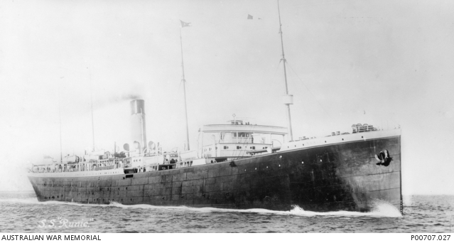
After training he embarked on HMAT Runic A54 on 19th February 1915 and landed in Egypt in March 1915. He was posted to Gallipoli on 8th May 1915 with the 8th Battalion. During this campaign he suffered with influenza and enteric fever, which saw him moved to Mudros on 22nd June 1915 and later to Alexandria.
He rejoined his unit at Gallipoli on 23rd November 1915. Only a week later he was evacuated with rheumatism; he rejoined his unit on 11th March 1916 at Serapeum Camp in Egypt.
Later that month Bill travelled with the 8th to Marseilles enroute to the Western Front. In April 1916 he was admitted to hospital with mumps and released on 18th May.
On 7th August 1916 he was wounded by shrapnel in the finger and later was accidently wounded in the lower jaw, right shoulder, both legs and both hands on 18th November 1916.
He was evacuated to England on 8th December and remained in hospital until March 1917 when he returned to Australia on the Hospital Transport Beltana arriving on 12th May 1917 and was discharged on 19th June 1917.
William Howard received the 1914/15 Star, British War Medal and the Victory Medal.
He passed away in 1961 at Heidelberg aged 71.
