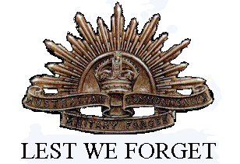
Geoffrey Hughes
Service No. 3294
Rank: Sapper
Unit: 6th Field Company Engineers
Geoffrey Hughes was born in Chee Foo China in 1892 and was living at “Whangaroa” Greensborough when he enlisted. His mother Mrs Janet Price (nee Cummings) was given as his next of kin was living at the same address at that time.
He was aged 22 years, 10 months and working as a Brass Finisher when he enlisted on 10th July 1915.
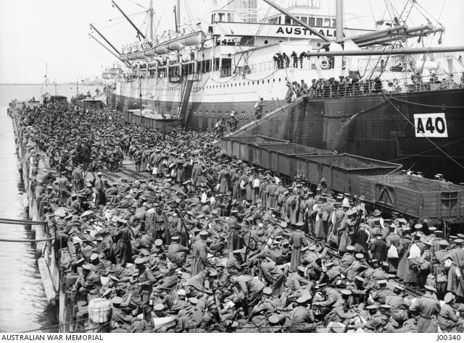
After training he embarked on HMAT Ceramic A40 on 24th November 1915 and was sent to Egypt then on to Marseilles where he arrived on 27th March 1916. Geoff was then sent to the Western front with the 6th Field Coy Engineers.
In December 1916 he was hospitalised with trench feet and taken to Edmundson Military Hospital. He was also suffering from bronchitis.
After recovering from this and fit again, he was transferred to the 17th Field Coy Engineers and based in England. On 2nd December 1917 he was again transferred to the 6th Field Coy Engineers and on 18th February 1918 he returned to Europe this time in Belgium.
His file notes he was hospitalised with sickness twice during March to May 1918 but doesn’t name the illness. He returned to Australia on the Castalia arriving on 30th May 1919 and was discharged on 22nd June 1919.
He received the 1914/15 Star, British War Medal and the Victory Medal.
In the post war period up to his death he lived at 75 Mountain View Rd, Montmorency and was described as an orchardist.

