David Iredale
Service No. 3654
Rank: Driver
Unit: 58th Battalion
David was born in Greensborough, the son of George Iredale and Maria Gilding in April 1880. He was aged 34 years, 6 months and working as a hospital attendant when he enlisted on 15th February 1918. His wife Gertrude (nee Starling) was given as his next of kin and living in Diamond Creek at that time.
David was the brother in law of Fred Starling DCM, MM and Walter David Starling DOW 18th May 1918.
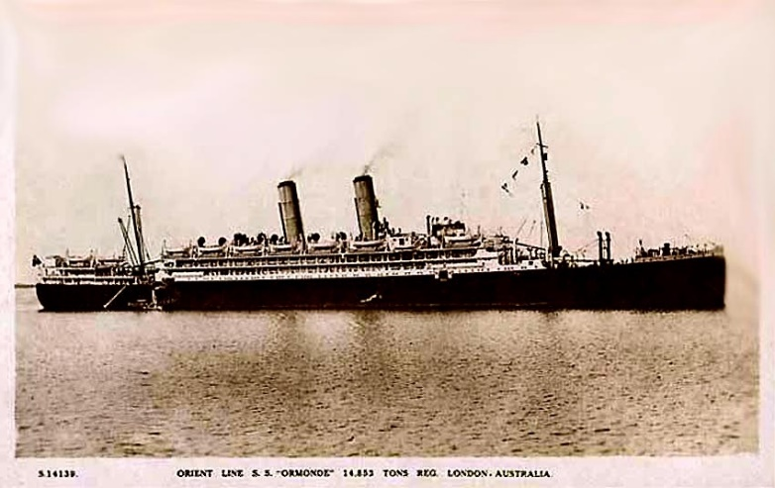
After commencing training he embarked on RMS Ormonde on 7th March 1918 and arrived at Suez on 30th April 1918.
He was placed in a segregation camp as he had had contacted with measles. When cleared from this he departed from Alexandria on the Indarra on 24th May 1918 and arrived at Southampton on 5th June 1918 and was transferred to the 14th Training Battalion at Codford to complete his training.
During this time it was detected that he had a double hernia received prior to enlistment. This rendered him unable to march for extended periods and he was boarded as unfit for service on 28th April 1919.
He returned to Australia on the Orontes arriving on 28th June 1919 and was discharged on 15th July 1919.
He received the British War Medal.
David passed away in 1947 at Heidelberg aged 67.

