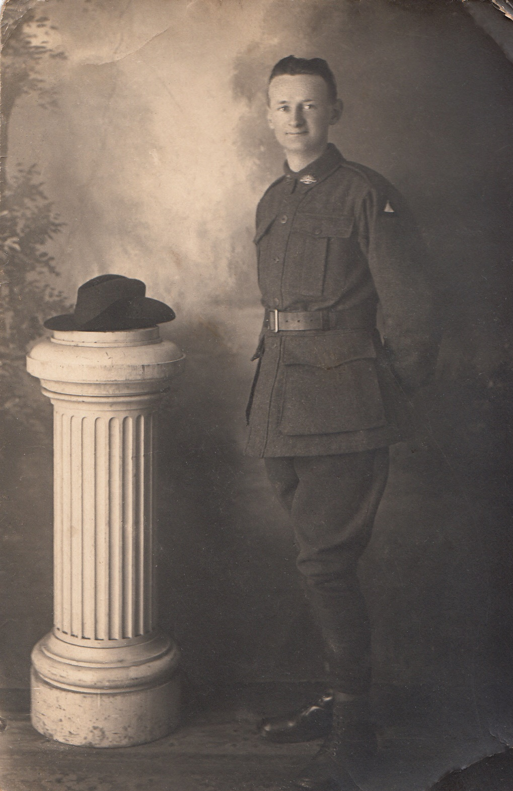
John Cecil Jessop
Service No. 822
Rank: T/Corporal
Unit: 8th Battalion
Early Days
John Cecil Jessop was born on 29th March 1892 in North Carlton. He was the second child and eldest son of John Coote Jessop and Louise Esther Portway.
Both his parents were born in Victoria. His father was employed as a telegraphist and Cecil (as he was known) started work at 14 as a telegraph boy.
He had an elder sister (Doris b. 1890), two younger sisters, (Dulcibell 1896 & Rosalind 1898) and three younger brothers, (Victor 24/7/1893, Rupert 1895 & Clarrie 11/8/1899).
War Service
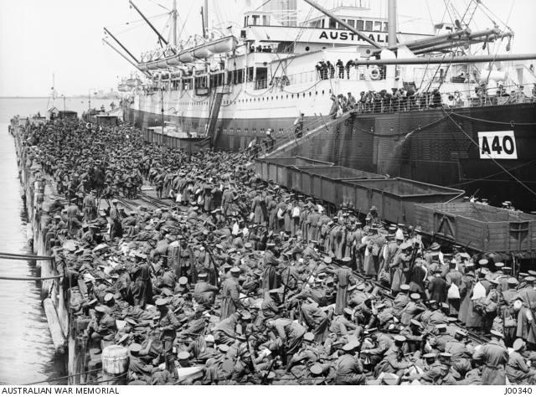
Cecil enlisted in the 1st AIF on 16th July 1915 and was assigned to the 12th Reinforcements of the 8th Infantry Battalion. He completed his basic training at Broadmeadows.
His occupation at the time of his enlistment is stated as a Baptist Minster and he was aged 23 years 5 months at that time.
Cecil embarked from Adelaide on HMAT Ceramic on 23rd November 1915.
He was sent to France and wounded in action on 25th July 1916. His record notes that he was ambulatory and walked to the Casualty Clearing Station. He is also listed as suffering from shell shock. On 25th August he rejoined his battalion, but he was in and out of hospital frequently until November that year. He later served with the “Anzac Corps” and 1st Australian Division.
On the 10th October 1918 he was transferred to the Australian Corps HQ where he served as a stretcher bearer for the remainder of the war and was promoted to temporary corporal.
At the completion of hostilities, he was awarded the 1914/15 Star, the British War Medal and the Victory Medal.
Cecil returned to Australia on 28th February 1919.
Post War Years - A Community Minded Individual
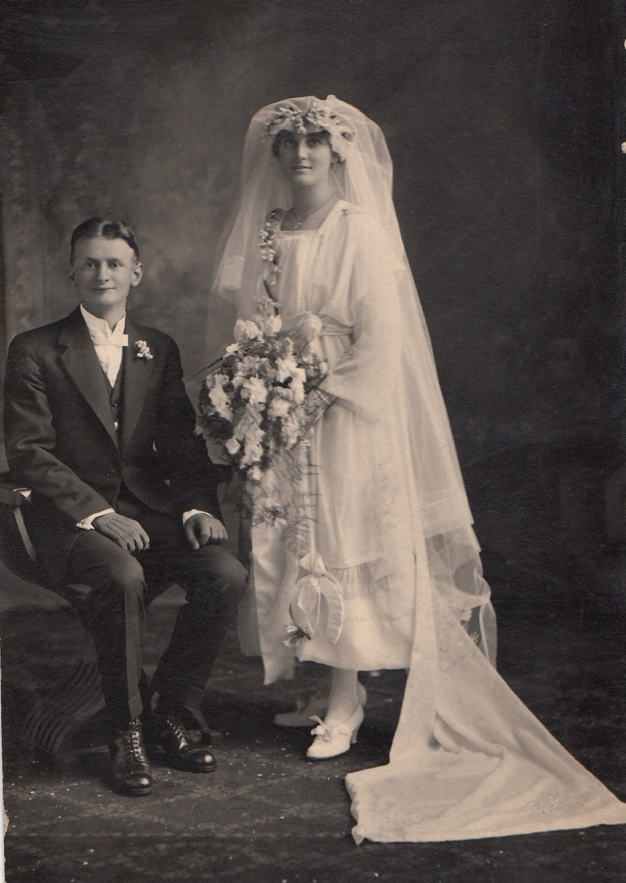
On 13th September 1919 Cecil married a fellow Baptist, Catherine Rose Robinson. He was employed as an accountant and worked his way up to become the manager of the mortgage and investment department of the Trustees, Executors and Agency Company Ltd.
Also in 1919 Cecil moved to Greensborough for health reasons. (Perhaps this was seen as a very healthy locality with lots of fresh air).
In 1923 Cecil joined the Diamond Valley Freemasons’ Lodge, No. 252 in Diamond Creek. He was a foundation member of the Greensborough Lodge, No. 374 which was consecrated on 22nd April 1925. He was Master of this Lodge in 1932.
In July 1924 Cecil was appointed as a Sworn Valuator under the Transfer of Lands Act for the Counties of Bourke and Mt Evelyn.
Cecil had bought a holiday house at Sorrento and in the Christmas holidays of 1940 to 1941 lent it to the Greensborough Scouts.
He was also on the Committee of the Greensborough Football Club and honorary auditor of the Greensborough Austin Hospital Auxiliary.
In 1930 Cecil was nominated as a candidate for Heidelberg Shire council elections for the Greensborough Riding. An article in the Hurstbridge Advertiser of 22nd August 1930 sheds some further light on his business activities.
He commenced business as an accountant and agent in 1923. J C Jessop Real Estate agents were located at the corner of Main Street and Grimshaw Street. In 1925 he formed the Greensborough Development Company Pty Ltd with himself as Managing Director. By 1930 this company had built 78 homes in the district.
He had been the Secretary of the “old hall society” and the Park Committee. The article claimed he had been closely associated with every forward movement designed for the advancement of the district.

Public Life
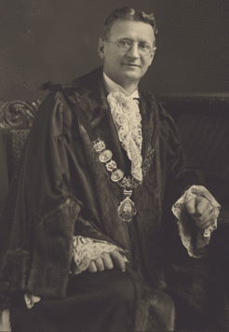
Part of his platform included the disproportionate way in which the Shire allocated road funding. The state government had awarded the Shire a Highway Grant to be spent on improving the Shire’s roads. Typically, it was allocated to each riding on a property value basis rather by amount of mileage in a riding. So, Ivanhoe with its 2 miles of roads got 690 pounds, while Greensborough with 11 miles got 190 pounds. (Not much had changed by 30th September 1964 when the Shire of Diamond Valley was formed.)
Cecil was successful in 1930 and remained on council until 1940. When elections were held during this time he was unopposed; a true testament to the satisfaction of the ratepayers in their councillor.
He was chosen as commissioner for Heidelberg on the Melbourne and Metropolitan Board of Works (MMBW) in 1934 and Mayor in 1935. In 1937, he was appointed vice chairman of the finance committee of the MMBW and finally in 1940, he was elected as Chairman of the MMBW.
As a result of this appointment he had to remove himself from all his public and civic commitments. He resigned from the Council and organised other people to operate his business interests. His successor as councillor was Albert K Lines who also was elected unopposed.
At this time, a local street was renamed in his honour. Jessop Street Greensborough had formerly been known as James Street. This was in honour of James Poulter who had lost his life at Beauvoir in France during the Great War.
In September 1942 Cecil was also appointed as a Magistrate to “Keep the peace in the Central, Northern, Southern, Eastern, Western and Midland Bailiwicks of Victoria.” That would have kept him busy!
At this time, the MMBW was not a popular organisation, it had low morale among its staff and money and labour were tight due to the war effort.
With his open management style, he was able to placate people on all sides and his concern for the well being of his workers meant the reputation of the MMBW became held in higher regard by the public. It is said that he would regularly take a cut lunch to work and eat in the staff canteen.
His careful financial management of the board during the war years had kept water rates low, but this proved inadequate when the post war building boom required the building of another dam. So building the Upper Yarra dam was started. However, it did not commence filling until 1957 and so Melbourne was again suffering from an inadequate water supply as it had been 100 years before, prior to the building of Yan Yean. Incidentally, the building of Yan Yean and the distribution of water from it caused the MMBW to be formed initially.
Statistics state that in 1942 145 new houses per year were being connected to the supply, by 1955-56 the figure was around 15,000.
In 1956 Cecil retired from the MMBW. But this was not an idle retirement.
Retirement
During his retirement, he built a cottage in the grounds of the Sutherland Homes where he had been Treasurer for many years.

In 1958, he published a book on the life and work of the founder of the homes Selina Sutherland. (1839 -1909).
He took on the role of manager of the homes until ill health forced him into the Diamond Valley Community Hospital which he had helped to found.
He passed away there on 15th March 1968.

