Arthur Edgar Judkins
Service No. 61168
Rank: Private
Unit: 6th Battalion.
Arthur Edgar Judkins was born in Woodend in 1900, the son of Percy Judkins and Annie Craig. At the time of his enlistment the family was living at Greensborough. He was 18 years and 1 month old and working as a Driver when he enlisted on 2nd March 1918.
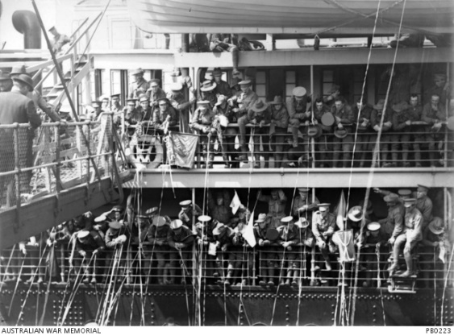
His next of kin was Percy Edgar Lucas Judkins (Father) c/o PO Greensborough who gave his consent for Arthur to enlist. Percy Judkins is buried in the Greensborough Cemetery.
After training he embarked on HMAT Barambah A37 on 31st August 1918 and landed in England in early November 1918. He was allocated to the 6th Battalion Reinforcements shortly after the cessation of hostilities.
He returned to Australia on the Khyber on 31st March 1919.
Arthur Judkins received the British War Medal and is commemorated on the Greensborough District Honour Board at the Greensborough RSL.
Arthur married Amy Simkin in 1926, they had a son. Sadly Arthur passed away 1955.
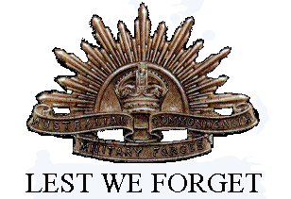
Arthur’s brother James was killed in action on 7th August 1915.

