James Judkins
Service No. 7507
Rank: Private
Unit: 1st Battalion
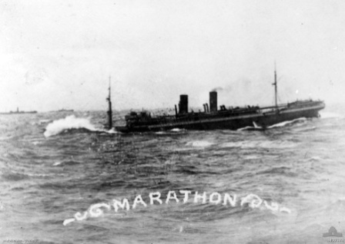
James was born in Woodend in 1895, the son of Percy Judkins and Annie Craig. At the time of his enlistment he was living at Mangalore. He was 22 years and 2 months old and working as a Farmer when he enlisted on 26th April 1917. His next of kin was his aunt Margaret Dixon.
After initial training he embarked on HMAT Marathon A74 on 10th May 1917 and landed England. He was hospitalised twice during his training period and eventually he was taken on strength in the 1st Battalion in France in March 1918.
Regrettably James was killed in action in France 11th August 1918 when an artillery shell hit his dugout.
Although he nominated as his next of kin Margaret Dixon, his Aunt; James’ medals went to Percy Judkins his father (letter 29th June 1921).
He received the Memorial Plaque, British War Medal and the Victory Medal.
James’ father Percy in buried in the Greensborough Cemetery.
James is commemorated on the Greensborough District Honour Board at the Greensborough RSL. James is on the Greensborough Fallen Soldiers’ Memorial.
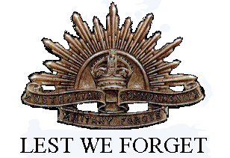
The Woodend WW1 Servicemen & Women allocated a tree on the Avenue of Honor for James 59 East.

