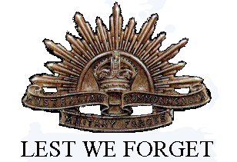
William Wandless Limmer
Service No. 250
Rank: Driver
Unit: 3rd Pioneer
William Wandless Limmer was born in Diamond Creek, the son of Henry William Wandless Limmer and Elizabeth Herbert in 1885. He was aged 30 years, 11 months and working as an orchardist at Nutfield when he enlisted on 8th December 1915. His father was given as his next of kin.
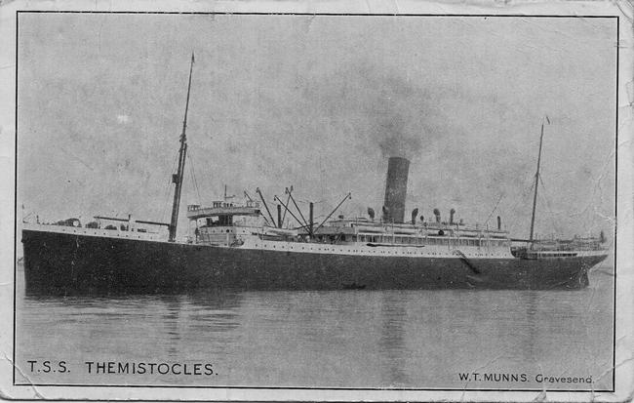
After commencing training he embarked on HMAT Wandilla A62 on 6th June 1916 and arrived at Plymouth on 26th July 1916 and completed his training in England during which time he was appointed as a Driver.

On 24th November 1916, he was transferred to France and taken on strength of the 3rd Pioneer Battalion. He attended the Veterinary School in Calais from 15th to 25th July 1917.
In December 1918 William Limmer contracted bronchitis which later developed into bronchial pneumonia. He was initially treated at 3 AGH in Abbeville and then removed to England where he was admitted to the 1st Birmingham War Hospital on Christmas Day 1918.
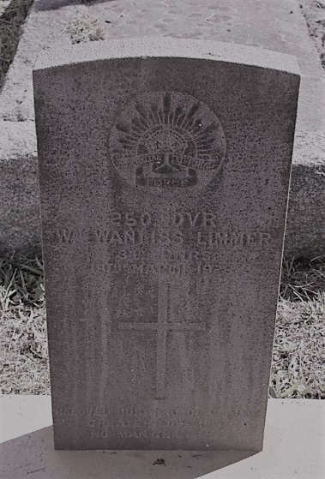
He returned to Australia on the HMAT Ascansius A11 arriving on 3rd April 1919 and was discharged on 11th May 1919.
His post war address was given as “Avelon” c/o Post Office Nutfield.
He received the British War Medal and the Victory Medal.
William passed away on 19th March 1928 at Diamond Creek aged 43. He is buried at Nillumbik Cemetery.

