Albert Keith Lines
Service No. 12805
Rank: Driver, later Extra Regimental Corporal
Unit: Australian Service Coy, 3rd Division Train
Albert was born in Albert Park, the son of Charles Cornelius Lines and Annie Elizabeth Seuling in 1897. He was aged 19 years, 1 month, working as a Draftsman and living at Greensborough when he enlisted on 25th April 1916.
His father was given as his next of kin.
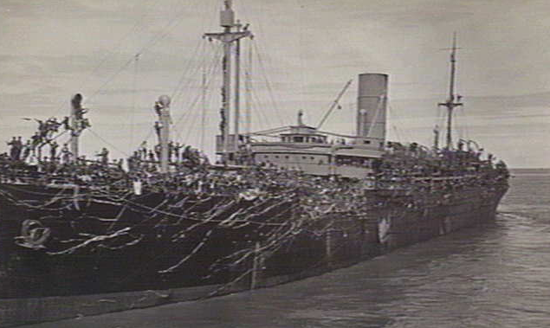
After commencing training, he embarked on HMAT Borda A30 on 20th October 1916 and arrived at Plymouth on 9th January 1917 and completed his training in England at Sutton Veny.
On 25th July 1918 he was transferred to France and taken on strength of the 3rd Division Train. On 19th June 1919 he was promoted to Extra Regimental Corporal.
He returned to Australia on the Pakeha arriving on 24th November 1919 and was discharged on 8th January 1920.
His post war address was given as Main Road, Greensborough. His house was where the BP Greenleigh Service station is and the original building was moved to the corner of Yan Yean and Young’s Road, Yarrambat. (This was demolished in early 2016).
He was elected as a local councilor for the City of Heidelberg and has a reserve named after him in Watsonia.
On 23rd February 1940, the Eltham and Whittlesea Shires Advertiser reported: “ Without opposition, Mr. Albert Keith Lines was elected to the vacancy in the Greensborough Ward of the Heidelberg City Council yesterday. When nominations closed, his was the only one which had been received. Councillor Lines is aged 42 years, an architect, and is President of the Victorian Society of Architects. He has been in private practice for more than 12 years, and has supervised considerable work in the metropolitan area, much of it being in the City of Heidelberg. His training and experience in his profession will enable him to render valuable service particularly in matters concerning building by-laws and the like.”

A.K.Lines received the British War Medal and the Victory Medal.
Albert Lines passed away in 1981 at Ivanhoe aged 84.

