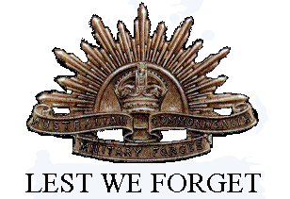
Henry Hensler Neville Littledike
Service No. 3092
Rank: Private
Unit: 37th Battalion, 10th Field Company Engineers, 38th Battalion
Henry Littledike was born in Poowong, Gippsland, the son of Henry Littledike and Abigail Glew in 1887. He was aged 29 years, 7 months, working as a bacon curer and living at Yando near Boort when he enlisted on 6th January 1917.
His widowed mother who lived at Greensborough was given as his next of kin.
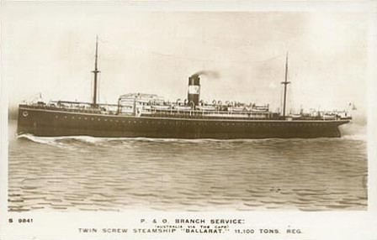
After commencing training he embarked on HMAT Ballarat A70 on 19th February 1917 and arrived at Plymouth on 25th April 1917 and completed his training at Southampton England.
On 26th August 1917 he was transferred to France and taken on strength of the 37th Battalion. He was hospitalised on 14th September 1917 and when released on 25th September was attached to the 10th Field Company Engineers.
On 10th August 1918 Henry was wounded in action by being gassed and was hospitalised again until 24th September 1918. On 12th October 1918, he was transferred to the 38th Battalion. On 31st October 1918, he was admitted to 3 AGH with influenza. On 6th November he was moved to England and was in Chatham hospital when the Armistice was signed.
He returned to Australia on the City of York arriving on 27th February 1919 and was discharged on 29th March 1919.
Henry Littledike received the British War Medal and the Victory Medal.
His post war address was given as c/o Post Office Werribee.
Henry passed away in 1954 at Yarram aged 67 and is commemorated on the Greensborough District Honour Board.

