James Lucas
Service No. 1961
Rank: Private
Unit: 57th and 60th Battalion
James Lucas was born in 1895 in Bundoora/Greensborough, the son of James Lucas and Lavinia Snell. At the time of his enlistment the family was living at Northcote. He was 22 years old and employed as a wicker worker when he enlisted on 25th March 1916.
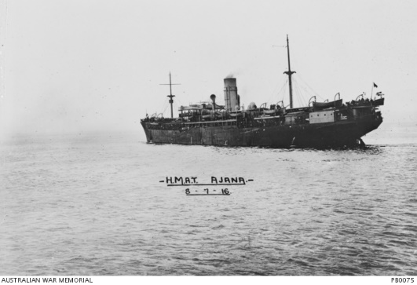
After training in Broadmeadows he embarked on HMAT Ajana A31 on 8th July 1916 and arrived at Devonport, England on 31st August 1916.
He completed his training at Larkhill with the 15th Training Battalion and was sent to France in December 1917. He was taken on the strength of the 60th Battalion on 17th February 1917. In March 1917 he was hospitalised with diarrhoea. He rejoined his unit on 1st April. On early December 1917 he was hospitalised with tonsillitis and returned to duty on 12th December.
On 29th September 1918 he was transferred to the 59th Battalion.
On 30th November 1918 he was wounded in action at The Somme and died of his wounds on 5th October 1918 in the 3rd Australian General Hospital at Abbeyville, France. He is buried at Abbeville Communal Cemetery Extension, France.
He was awarded the British War Medal, Victory Medal and Memorial Plaque.

