Robert Lindsay Medley Maddison
Service No. 6951
Rank: Lance Corporal
Unit: 24th Battalion
Robert Lindsay Medley Maddison was born in Rockhampton in 1898, the son of Lewis Maddison and Helen Isabel Elms. At the time of his enlistment the family was living at Greensborough. He was 18 years and 3 months old and working as Farmer when he enlisted on 16th August 1916. Robert had served as a cadet prior to enlisting. He named his father as next of kin, Lewis Maddison of “Hareah” Eltham Road, Greensborough.
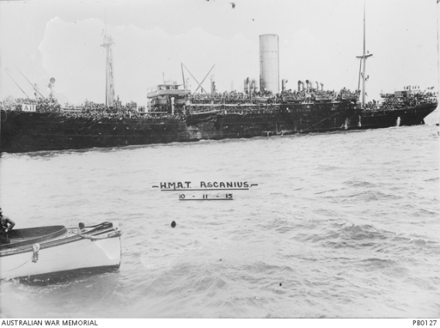
After training at Royal Park and Ascot Vale, he embarked on HMAT Ascanius A11 on 11th May 1917 and landed in France. He was taken on strength in the 24th Battalion and saw active service on the Western Front in France. He was gassed several times in March and April 1918 but returned to his unit.
Robert was killed in action 1st September 1918 in France. He is buried in Peronne Communal Cemetery Extension, Picardie, France.
He received the British War Medal, Victory Medal, Memorial Plaque and Scroll.
Robert Maddison is commemorated on the Greensborough War Memorial and the Greensborough District Honour Board at the Greensborough RSL.
Robert’s brother Hastings also served in Gallipoli and France, returning on the 7th May 1919.
