David Alfred Mann

Service No. 61891

Rank: Private

Unit: Australian Graves Detachment

David Alfred Mann was born in Janefield in 1899, the son of David Alexander Mann and May Thomas. David’s next of kin was his father David Mann living on the farm at Thomastown.

He was 19 years old and working as a Farmer when he enlisted on 4th June 1918.

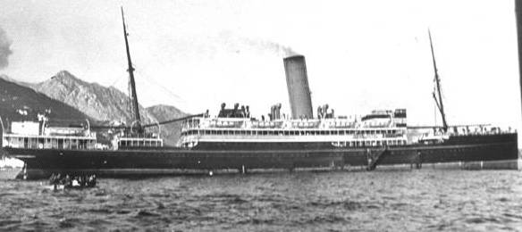After training at Broadmeadows, he embarked on SS Zealandic on 5th October 1918 arriving in England after the cessation of hostilities. He was allotted to the 22nd Battalion Reinforcements in December 1918, and then to the Australian Graves Detachment in France in March 1919.

He returned to Australia on the Anchises on 8th October 1919.

He received the British War Medal.

David Mann passed away in 1974 at Strathewen.

