Alfred William McDougall
Service No. 68704
Rank: Private
Unit: 14th General Reinforcements
Alfred was born in Brunswick, the son of David Campbell McDougall and Charlotte Elizabeth Mersion.
At the time of his enlistment his address was Sydney Road, Brunswick. His father and mother were living in Greensborough.
Alfred was 27 years and 10 months old and working as a Master Tailor when he enlisted on 6th July 1918.
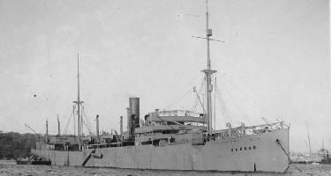
After training, he departed on HMAT Boonah A36 leaving on 22nd October 1918, but this vessel was recalled due to the end of hostilities and he returned to Australia on 20th December 1918.

Alfred McDougall received the British War Medal although he did not see active service.
