Reginald Harold McDowell
Service No. 4762
Rank: Private
Unit: 22nd Battalion & 2nd Division Salvage Company
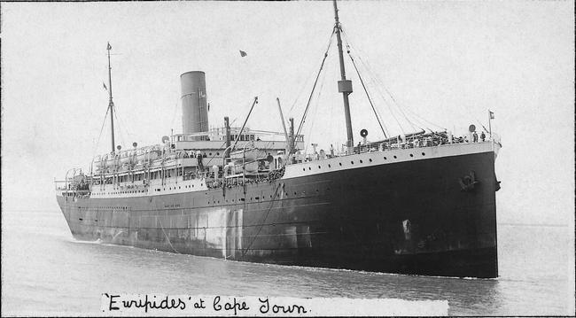
Reginald Harold McDowell was born in Greensborough in 1891, the son of William McDowell and Susan Poulter. At the time of his enlistment the family was living at Diamond Creek. He was 24 years and 5 months old and working as a laborer when he enlisted on 22nd January 1916.
After training he embarked on HMAT Euripides A14 on 4th April 1916 and landed in France.
He was taken on strength in the 22nd Battalion on 5th October 1916 and saw active service on the Western Front in France.
On 24th January 1917 he was transferred to the 2nd Division Salvage Company.
He returned to Australia on the Chemnitz on 5th September 1919 and was discharged on 28th October 1919.
He received the British War Medal and the Victory Medal.
Reg McDowell is commemorated on the Greensborough District Honour Board at the Greensborough RSL.
