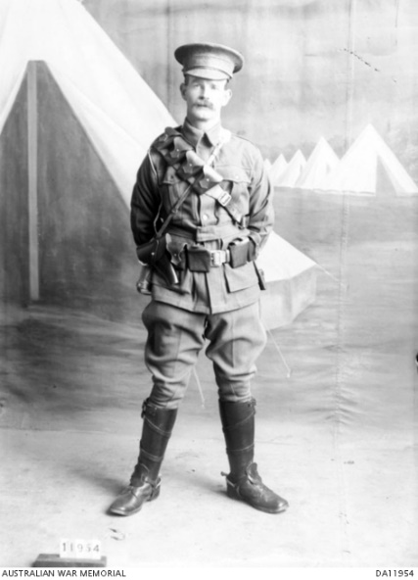
Frank Henry McGill
Service No. 1502
Rank: Lance Corporal
Unit: 4th Light Horse Regiment “A” Company
Frank Henry McGill was born in Ballarat in 1877, the son of Andrew John McGill and Emily Ann Elizabeth Hitchins.
Frank married Hetta Olivia Florence Haslett in 1899 and they were living in Bundoora at the time of his enlistment.
He was aged 37 years and working as a farmer when he enlisted on 7th July 1915.
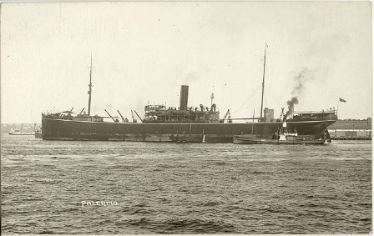
After training he embarked on HMAT Palermo A56 on 19th October 1915 and landed in Egypt.
He was taken on strength in the 4th Light Horse and saw active service with the Desert Column.
He returned to Australia on the Margha 4th March 1919.

Frank Henry McGill received the 1914/15 Star, British War Medal and the Victory Medal.
Frank passed away in Reservoir on 31st July 1949.

