Kenneth Donald McKenzie
Service No. 11736
Rank: Gunner
Unit: 12th Field Artillery Brigade
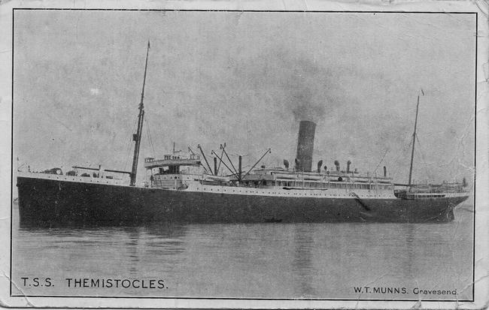
Kenneth Donald McKenzie was born in Greensborough in 1891, the son of William McKenzie and Sarah Walles. At the time of his enlistment he was living at 16 Murray Street, Moonee Ponds. He was 24 years and 5 months old and working as a farmer when he enlisted on 27th July 1915. He named his wife Alice as next of kin.
After training he embarked on HMAT Themistocles A32 on 28th January 1916 and landed in Egypt. He was taken on strength in the 12th Field Artillery on 21st March 1916 at Tel El Kebir. On 2nd June 1916 he embarked for Marseilles and the Western Front.
In March 1917 he was briefly hospitalised from sickness. After this he served as a Gunner in France until 26th April 1917 when he was appointed as a Driver.
In 1917 his unit was redesignated as 12th Division Field Artillery Brigade. (12th FAB)
He received “Blighty Leave” on 21st September 1918. During this leave he was hospitalised again this time for a period of 60 days. When he was released from hospital he was posted for duty to Bulford Hospital.
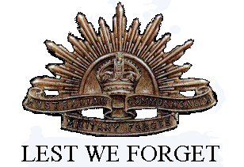
He returned to Australia on the City of Exeter on 24th August 1919.
Kenneth McKenzie received the British War Medal and the Victory Medal.

