William Henry McLean
Service No. 1935
Rank: 22nd Battalion
Unit: 22nd Batt & 2nd Division Salvage Company
William was born on 6th May, 1894 in Bundoora, he was one of twelve children born to William McLean and Kate Louisa Matthews.

Before enlisting William drove a horse-wagon collecting milk and cream from surrounding farms and delivering it to Melbourne. He also drove loads of wood from The Dandenongs to Melbourne.

His parents didn't want him to go to war, and would not sign his papers. But, as soon as he turned twenty-one and he didn't need his parents’ permission he enlisted on the 17th June, 1915. He named his father as next of kin William McLean of McLean’s Road, Bundoora.

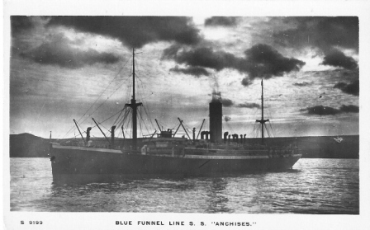
After training he embarked on HMAT Anchises A68 on 26th August 1915 and landed in Egypt. He was taken on strength in the 22nd Battalion at Gallipoli on 25th October 1915. On 5th November he received a shrapnel wound to his left arm after which he was evacuated to Malta on 12th November. This wound became severe and on 31st December 1915 he was sent to England for further treatment. He was admitted to Wandsworth Hospital on 8th January 1916.
His treatment kept him in England for an extended period and after being in a number of hospitals and the No. 6 Training battalion he finally rejoined his unit in France on 24th June 1917.
On 4th October 1917 he was wounded in the left arm and fingers of his left hand. He was moved to the 64th Field Ambulance for initial treatment and then again moved to 57th General Hospital and in turn to the 7th Convalescence Depot on 14th October 1917. On 29th October 1917 he rejoined his unit.
In March 1918 he was hospitalised for a number illnesses and again in 1919.
He returned to Australia on the Takada on 7th September 1919 and was discharged on 6th November 1919.
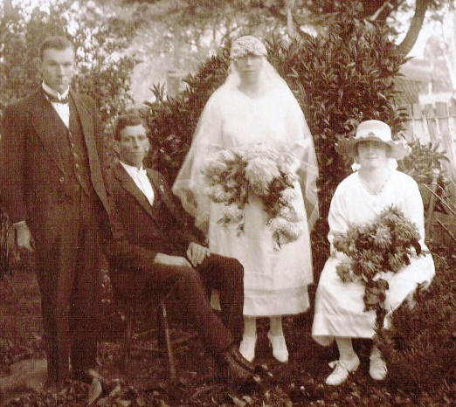
He received the 1914/15 Star, British War Medal and the Victory Medal.
William married Ila Annie Elizabeth Lucy Pierrehumbert 1st May, 1921 in Brandy Creek (Near Warragul); they had five daughters.

William was allotted a Soldier Settlement farm at Allambee Reserve near Mirboo North in Gippsland in 1922. The country there is very steep and as William had serious breathing problems it made it a difficult job. Ila became a District Community Nurse. She often nursed people who were ill or hurt on farms and she was also a midwife. They had a telephone installed because Ila was a nurse.
William and Ila on their wedding day

The property also had another Soldier Settler, Hugh Tierney Service No. 11905.
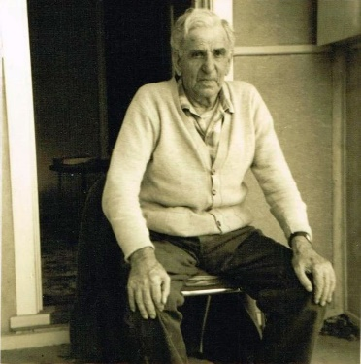
William McLean at home in Nilma 1970

Because of the steep hills, the property would hardly keep one family, but they battled on till 1928, when Ila's father helped to have them transferred to a better property at Bona Vista Road, Nilma, near Warragul. William was able to run a dairy on this property.
During their life together William and Ila had five daughters.

William passed away on the 19th May 1973, in Nilma. He was 79 years old and Ila passed away 31st December 1966, she was 74. Theyare both buried in Warragul Cemetery.

William is listed on the Greensborough State School, Greensborough Methodist Sunday School and Greensborough District Honour Boards.
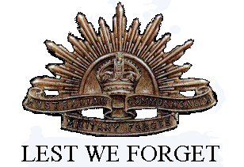
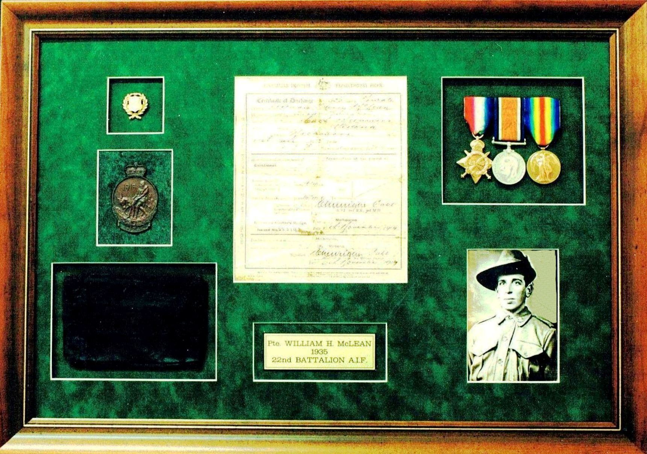
William McLean's War Memorabilia

