Donald Duncan McLennan
Service No. 577
Rank: Driver
Unit: 2nd Cyclist Battalion & 4th Machine Gun Battalion
Donald Duncan McLennan was born in Healesville in 1898, the son of Donald McLennan and Isabella Stoddart Disher.
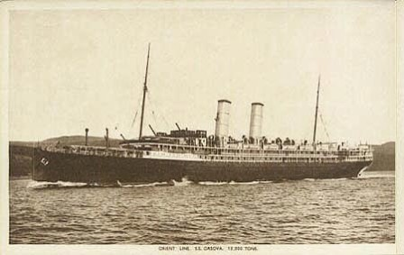
He was aged 18 years, working as an orchardist and living at “Woodside”, Tanck’s Corner when he enlisted on 3rd June 1916.
After training he embarked on HMAT Orsova A67 on 1st August 1916 and landed in France. He was taken on strength in the 2nd Cyclist Battalion and on the 22nd May 1917 he was taken on strength in the 4th Division Machine Gun Company. On 3rd July 1917 he joined 17th Machine Gun Company. From 7th September 1917 he saw active service in France.
On 28th November 1917 he was appointed as a Driver.
He returned to Australia on the Ajana A31 on 11th October 1919 and was discharged on 25th November 1919.
Donald McLennan received the British War Medal and the Victory Medal.
Donald married Lilian Beale in 1939.
He passed away in Heidelberg on 21st February 1965.
