Donald McMillan
Service No. 6436
Rank: Private
Unit: 21st Battalion, 24th Battalion & 5th Division Train.
Donald McMillan was born in St Helena in 1891, the son of Donald McMillan and Marjory Hewitt.
He was aged 23 years and working as a labourer and living at the Metropolitan Farm Werribee when he enlisted on 23rd June 1915.
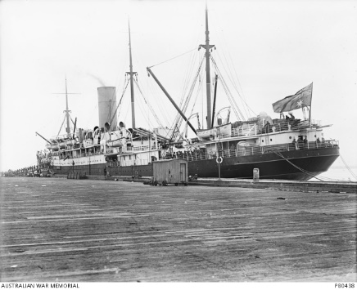
His first application was rejected on medical grounds as he was suffering from rheumatism and discharged on 17th July 1915. Don reapplied again on 7th November 1916 and this time was accepted into the 21st Battalion.
After training he embarked on HMAT Hororata A20 on 23rd November 1916 and landed in England on 29th January 1916 to complete his training. He arrived in France on 22nd May 1917.
In October 1917 he was hospitalised with trench fever and returned to France in January 1918.
He was transferred to the 24th Battalion on 13th October 1918. Then on 31st October 1918 he was transferred to the 5th Division Train.
He returned to Australia on the Runic A54 on 10th June 1919 and was discharged on 9th October 1919.
Donald McMillan received the British War Medal and the Victory Medal.
Donald passed away in Ballarat in 1972.
