William McRitchie
Service No. 957
Rank: Private
Unit: 37th Battalion & 5th Battalion
William McRitchie was born in Edinburgh in 1896, the son of Robert McRitchie whose address was 15 Giffard Park Edinburgh.
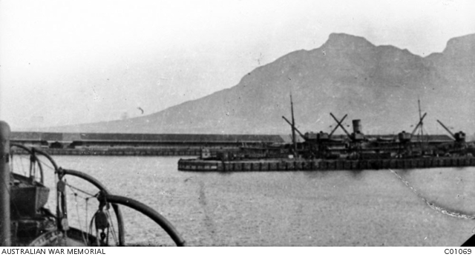
He was aged 20 years 6 months, working as a fireman and living in Greensborough when he enlisted on 27th February 1916.
After training he embarked on HMAT Persic A34 on 3rd June 1916 and landed in England on 25th July 1916 to complete his training. He arrived in France on 16th September 1916 and he was transferred to the 5th Battalion.
William suffered from trench foot and influenza during his time in the service and was hospitalised a number of times.
He returned to Australia on the SS Delta 15th May 1919 and was discharged on 15th May 1919.
William McRitchie received the British War Medal and the Victory Medal.
After the war he lived in Surry Hills NSW.
