David John Medhurst
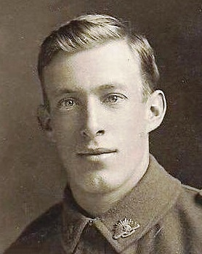
Service No. 3190
Rank: Private
Unit: 8th Battalion
David John (Jack) Medhurst was born in Lilydale in 1894, the son of David Thomas Medhurst and Martha Ruston. At the time of his enlistment the family was living at Greensborough, where David snr ran Medhurst’s Fruit Shop and wrote for the local paper. Jack was 21 years old and working as an orchardist when he enlisted on 26th July 1915. He embarked on HMAT Commonwealth A73 and landed in Marseilles. He was taken on strength 24th February 1916 and saw active service in France.
The following letter from Jack was received by his father and published in the local paper in July 1916. Three weeks later Jack was killed in action.
“Letters from the Front. A NARROW ESCAPE. The following letter has been received from Private Jack Medhurst, from somewhere in France, by his father in Greensborough. Dear all at home, Just a few lines to let you know that so far I am still safe and sound. I recently got three letters from home in a bunch. They were very welcome. I have not yet received any of the presents you have sent me, mentioned in previous letters. Well, there is not much news to tell you, although we had a bombardment the other night. Fritz got angry with something, and tried to blow us off the map, but he didn't get this child, although it was near enough. You would have smiled to see us crawling on our tummies along the wet trench. I was wet through when we got to our post. We were sitting in the trench, and Harold Potts was in front of me, when a great shell whizzed over head and burst. It was that close that it lifted my hat, and the flare burnt our faces. I can tell you that I felt myself to see if I was all there, and Harold says he saw things for the rest of the night. It was a lovely display of fireworks, but we all got out safe. Our battalion is known as "the lucky 8th." The other day we went to raid a trench, and crossing no man's land we were shelled the whole time, but none of us got hit. It was hot work while it lasted, but we got out of the scrape without losing a man. We are billeted in a loft belonging to a farmhouse. We are jolly comfortable, and there is plenty of straw for bedding. None of our chaps can talk French, and our ''landlady" - all the men are away at the fight - can't talk English, but we get on all right by signs, and it's amusing to see the old lady lining up with her plate at dinner time for some stew. We have a piano here, and Fred Starling makes things hum. There's plenty of noise, if not much melody. I saw Dug. Whittingham the other day, but had not the chance to speak to him. He was just going into the trench as I was leaving. I saw Jeff Hughes, and we had a long pitch. He hadn't seen any of the 'Borough boys since he left, so you may be sure there was plenty to talk about. It's very cold here, plenty of snow, and a great contrast to Egypt, but we all like over here better. We have had a great treat. A detachment was taken over to England for a spell. I am sending an "Anzac" book from London. I must ring off now. With best love to all at home - Yours, Jack.” Heidelberg News and Greensborough, Eltham and Diamond Creek Chronicle Saturday 8 July 1916. (Retrieved from Trove 17/7/2014)
David was killed in action 28th July 1916 in France in the vicinity of Pozieres.
David John Medhurst is commemorated on the Villers-Brettoneux Memorial and in Greensborough on the Fallen Soldier’s Memorial, Greensborough Primary School Honour Board and the Greensborough and District Honour Board at the Greensborough RSL.
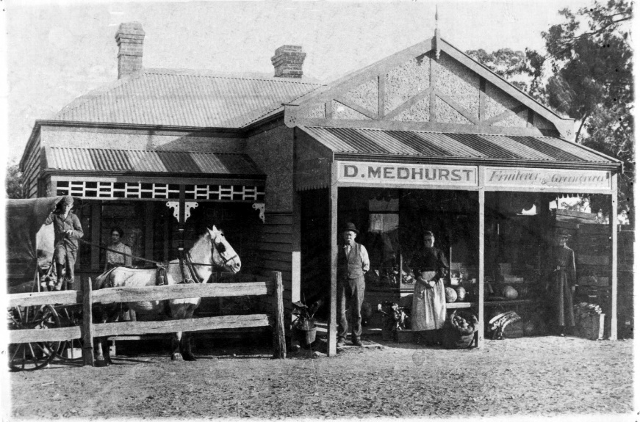
The Medhurst family outside their fruit shop. David is the young boy on the left
