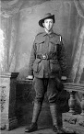John William Medhurst

Serial No. 3760

Rank: Private

Unit: 56th Battalion

John William Medhurst was born in Lilydale in 1900, the son of David Medhurst and Martha Rustin.

He was aged 17 years 9 months and working as a trimmer; he had been living in Greensborough when he enlisted in Sydney on 17th September 1917.

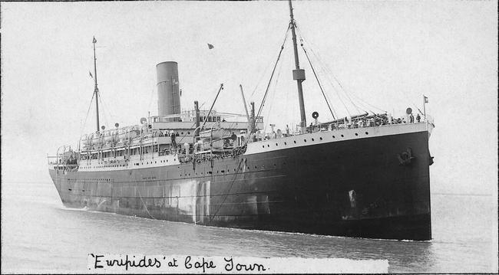John had been rejected in Melbourne for being too young and so travelled to Sydney to be attested there under the false name of John McPhee. He gave has mother’s name for next of kin and her address as Greensborough.

After starting training he embarked on HMAT Euripides A14 on 31st October 1917 and landed in England on 26th December 1917 to complete his training. He arrived in France on 17th April 1918 and he was taken on strength to the 56th Battalion.

John was diagnosed with effort syndrome in March 1919.

He returned to Australia on the SS Karoa 8th May 1919 and was discharged on 25th July 1919.

John Medhurst received the British War Medal and the Victory Medal.

In Greensborough, John is commemorated on the Greensborough and District Honor Board at the RSL and on the Greensborough Primary School Honour Board.

