William Melrose
Service No. 2729
Rank: Air Mechanic 2nd Class
Unit: Australian Flying Corps
William Melrose was born in Leith Scotland on 1st June 1885. His wife Mrs Emma Melrose was given as his next of kin.
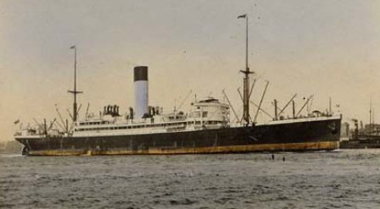
He was aged 32 years 6 months, working as a wood worker and living in Macleod when he enlisted on 14th December 1917.
After training he embarked on HMAT Nestor A71 on 28th February 1918 and landed in England on 20th April 1918.
He returned to Australia on the Kaiser-i-hind on 15th May 1919 and was discharged on 1st July 1919.

William Melrose received the British War Medal and the Victory Medal.
