Walter Raywood Menzies
Service No. 2260
Rank: 2nd Lieutenant
Unit: Australian Flying Corps
Walter Raywood Menzies was born in Sydney on 17th June 1899. His mother Mrs Adeline Hunt was given as his next of kin.
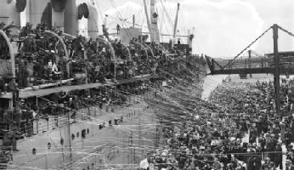
He was aged 18 years 1 month and still a student and living at “Woodlands” Greensborough when he enlisted on 26th July 1917. Prior to enlisting he had a 2 year service period in the Air Cadets.
After training he embarked on HMAT Aeneas A60 on 30th October 1917 and landed in England on 27th December 1917.
In England he attended various Air Schools before eventually graduating as a Pilot on 1st April 1919.

He returned to Australia on the China on 8th June 1919, where he was listed as dangerously ill with pneumonia. He was discharged on 20th December 1919.
Walter Raywood Menzies received the British War Medal.
In Greensborough, Walter Menzies is commemorated on the Greensborough and District Honor Board at the RSL and on the Greensborough Primary School Honour Board.
