Jonathan Lionel Mills
Service No. 3851
Rank: Lance Corporal
Unit: 8th and 7th Battalion
Jonathan Lionel Mills was born in 1895 in Upper Diamond Creek, the son of George Morgan Mills and Emma Qualtrough. Jonathan was one of four brothers to enlist.
At the time of his enlistment Jonathan was living at Essendon. He was 20 years old and working as a sleeper cutter when he enlisted on 26th June 1915.
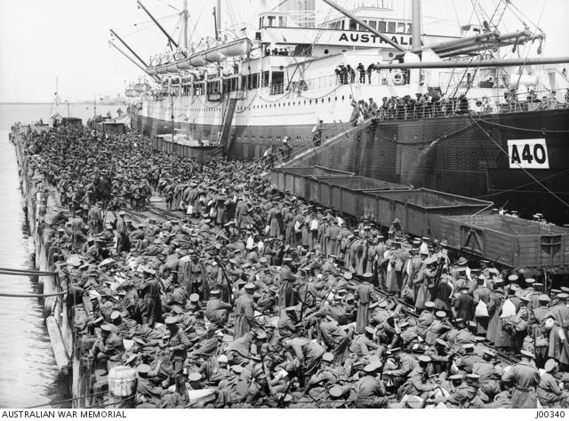
After training in Ascot Vale he travelled on HMAT Ceramic A40 and landed in Alexandria. After proceeding to France, Jonathan joined an Entrenching Battalion in March, before being taken on strength in France mid July 1916.
On the 25th June, he had a minor casualty, returning to the field on the 14th July 1916.
On the 18th August, 1916, Jonathan suffered a shell wound in his left shoulder, after treatment in the field he was transferred to England. He was treated in Weymouth, England, and in November, 1916, the wound was described as “superficial”.
In January 1917, Jonathan rejoined his battalion, and in April was promoted to Lance Corporal, aged 22.
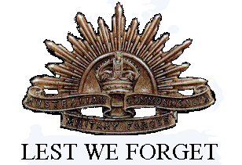
On the 13th October 1917, Jonathan Lionel Mills was reported missing in action in Belgium, confirmed killed in action on 20th October. Officially he was killed in action 4th October 1917. He is buried at Buttes New British Cemetery, Polygon Wood Zonnebeke.
Jonathan Lionel Mills was awarded the 1914/15 Star, British War Medal, Victory Medal and Memorial Plaque.

