William Austin Mills
Service No. 386
Rank: Sergeant
Unit: 7th Battalion
William Austin Mills was born in Upper Diamond Creek (Plenty) in 1888, the son of George Morgan Mills and Emma Qualtrough.
He was aged 25 years 10 months and working as a labourer at Upper Diamond Creek when he enlisted on 5th September 1914.
He was one of four brothers from the same family who volunteered for the war.
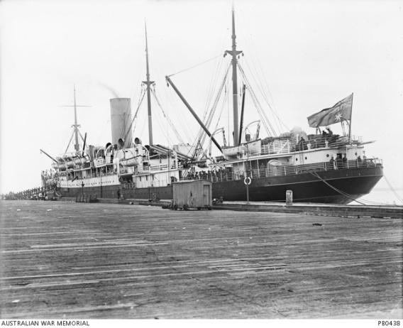
After initial training he embarked on HMAT Hororata A20 and disembarked in Egypt on 21st October 1914. After further training he departed for the Dardanelles and his records show him as being a patient on the Hospital Ship Galika on 24th April 1915.
On 22nd May 1915 he was wounded in action at Gallipoli and in July 1915 had a bout of influenza which saw him hospitalised on the Hospital Ship Soudain.
In August he received a wound to his ear and was treated for this in Cairo.
On 23rd September 1915 he rejoined his unit at Sarpi Camp on Lemnos. Later that year he also suffered a bout of dysentery.
After the evacuation of Gallipoli he was stationed at Tel el Kebir until he embarked for Marseilles and the Western Front on 20th March 1916 and arrived there on 31st March.
On 5th August 1916 he was promoted to Lance Corporal and on the 11th August to Corporal and on the same day Lance Sergeant. September 1916 saw him sick in hospital again.
William was Mentioned in Dispatches for a trench raid on 30th September 1916 and on 6th October 1916 he was promoted to Sergeant.
On 22nd December 1916 he was wounded in action with gunshot wounds to his left foot. This event fractured his foot and he was transferred to the Norfolk War Hospital. He was released from hospital on 14th May 1917.
After various postings in England with Training Battalions, he rejoined his unit in France on 25th August 1917. Further sickness had him returning to England later that year.
On 23rd February 1918 he again rejoined his unit in France after more training postings. On 6th July 1918 he was wounded for a third time with gunshot wounds to his arm and leg and once again returned to England. Sickness complicated his recovery this time and he wasn’t released until 10th September 1918. He was still in England when hostilities ceased.
He returned to Australia on the Marathon on 19th March 1919 and was discharged on 23rd March 1919.
He received the 1914/15 Star, a Mention In Dispatches, British War Medal and the Victory Medal.
He died in 1967 at Armadale aged 78.
