James Alexander Mitchell
Service No. 6538
Rank: Private
Unit: 7th Battalion
James Alexander Mitchell was born in Greensborough in 1887, the son of Henry Mitchell and Mary Anne Gordon. At the time of his enlistment the family was living at Greensborough. He was 29 years and 1 month old and working as Engineer when he enlisted on 20th July 1916. His next of kin was Mr. Henry Mitchell (father) of Hailes St. Greensborough.
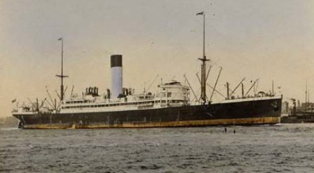
After training he embarked on HMAT Nestor A71 on 2nd October 1916 and landed in France. He was taken on strength in the 7th Battalion and saw active service on the Western Front in France.
On 23rd April 1917 he received gunshot wounds to his legs and was moved to the Central Military Hospital at Fort Pitt in England.
James Mitchell returned to France on 21st July 1917 and rejoined his unit on 5th August 1917.
On 4th October 1917 he was serving in Belgium when he was again wounded. This time in the left arm & face and rejoined his unit on 3rd November 1917.
On 18th May 1918 he was wounded a third time when he was gassed and shot in the chin, arm and received damage to his right eye.
He returned to Australia on the HT Medic D21 on 11th October 1918. James Mitchell was discharged from the A.I.F. on 4th December 1918 at Melbourne, as medically unfit. His disability arose from the gunshot wound in his right eye, right eye excised.
He received the British War Medal and the Victory Medal.
James Mitchell is commemorated on the Greensborough State School Honour Board and on the Greensborough and District Honour Board at the Greensborough RSL.

James’ brother William married Rose Amiet.
Sadly James passed away at Prince Henrys Hospital, on the 7th April 1944, and is buried in the Greensborough Cemetery.
