George Frederick Moore

Service No. 515

Rank: Lance Corporal

Unit: 39th Battalion and 14th Field Artillery Brigade

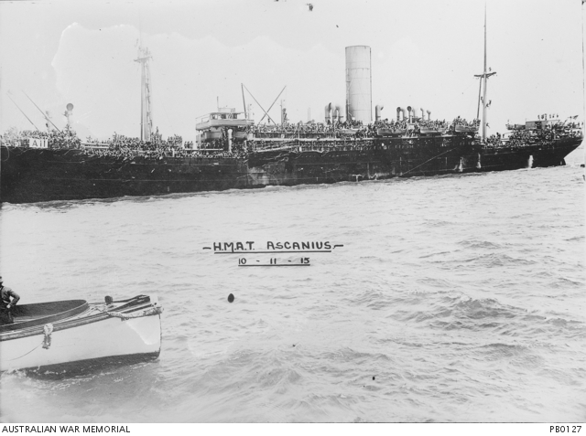George Frederick Moore was born in Sydney in 1889, the son of Lillie Moore of ‘Sunny Nook’ Diamond Creek. At the time of his enlistment George was living at ‘Riverglen’ Eltham. He was 26 years old and working as a farmer when he enlisted on 25th January 1916. George was promoted to Lance Corporal on 1st May 1916.

After training in Ballarat George travelled on HMAT Ascanius A11 and landed at Southampton. He proceeded to France in November 1916.

George Moore was wounded in action on Christmas Day 1916 and invalided to England in February 1917 suffering a gunshot wound to his left leg. When recuperated, George was sent to Windmill Hill Camp, Persham Downs England where he was detached for duty with the 17th Light Trench Mortar Battery (June 1917), then on to the Bombing School Lyndhurst in July where he qualified as a bombing instructor. In August 1917, George proceeded to France where he rejoined the 39th Battalion. His second wounding was a gunshot wound to the abdomen which saw him invalided once more to England (October – December 1917). Despite this being a ‘severe’ wound, the report from England is that he was ‘progressing favourably’. In December, his mother was concerned about her son and asked if there was any quick way of getting a letter to him after he wrote to her ‘*saying he had not heard from me for some time, yet I write to him every week*’.

In May 1918, George reverted to ‘Gunner’ and was appointed Driver; he once again proceeded to France and was taken on strength with 14th Field Artillery Brigade in September 1918.

George Moore was wounded in action and died of his wounds 23rd October 1918 in France. He is buried at Vadencourt British Cemetery, Maissemy France.

He was awarded the British War Medal, Victory Medal and Memorial Plaque.

George Frederick Moore is commemorated in Greensborough on the Greensborough Primary School Honour Board.

