Charles Edward Morgan
Service Nos. 954 & 7526
Rank: Private
Unit: 6th Battalion
Charles Edward Morgan was born in Bundoora about 1891. His wife Mrs Emma Morgan was given as his next of kin, Emma’s address was Lara Lake.
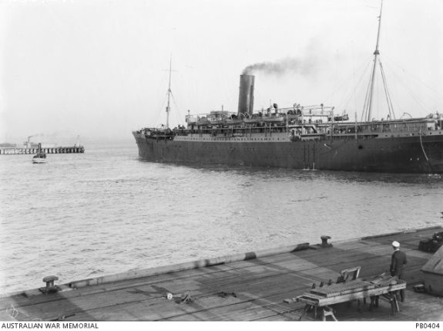
He was aged 22 years 2 months and employed as a baker when he enlisted on 21st August 1914.
After training he embarked on HMAT Euripedes A14 on 20th October 1914 and landed in Egypt on December 1914.
Charles was not an ideal soldier during his brief time in Egypt. In the period from 18th December 1914 to 25th January 1915 he was absent without leave (AWOL) on 8 separate occasions.
Ultimately he was returned to Australia departing on the Kyarra on 5th February 1915. His file has the following comment from his Commanding Officer: “He is absolutely unamenable to military discipline, and is unlikely to become an efficient soldier.”
He returned to Australia on 11th March 1915 and was discharged on the same day.
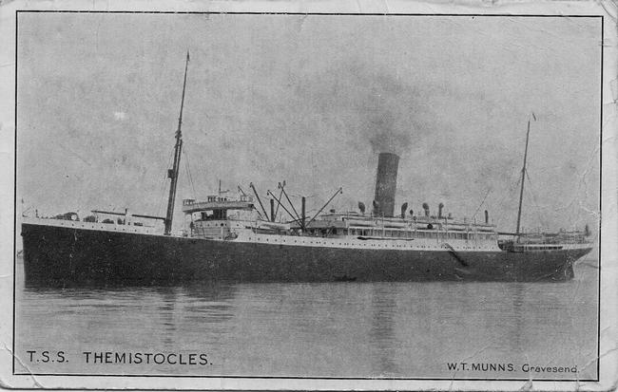
On 28th July 1917, Charles re-enlisted as a member of the 25th Reinforcements to the 6th Battalion. He again embarked on the 4th August 1917 on the HMAT Thermistocles A32 and on 3rd October 1917 he was placed in the 2nd Training Battalion in Durrington England.
Charles joined the 6th Battalion in France on 19th March 1918 and on 25th August 1918 he was gassed and invalided to England for hospitalization.
During this second enlistment Charles was again AWOL on a few occasions.
He returned to Australia on 8th October 1919 on the Anchises and was discharged on 29/11/1919.
He received the British War Medal and the Victory Medal. An application for the 1914/15 Star was rejected, due to his poor service record during his first enlistment.
Charles Morgan passed away on 4th November 1940.
