Donald Vary Paterson
Service No. 2266
Rank: Driver
Unit: Australian Flying Corps & Australian Graves Detachment
Donald Vary Paterson was born in Beechworth in 1896. He was the son of Henry Francis Paterson and Sarah Sampson. His father was given as his next of kin and they were living at “Weerona” Greensborough at the time of his enlistment on 30th July 1917.
His older brother Ernest Russell Paterson Serial No. 436 had enlisted in 1915.
Don was aged 21 years 2 months and employed as a bank clerk at that time.
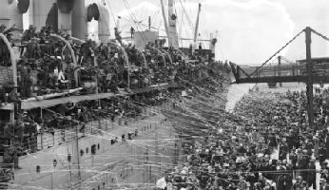
After training he embarked on HMAT Aeneas A60 on 30th October 1917 and landed in England on 26th December 1917.
Don served in England with the Australian Flying Corps and the 4th Motor Transport Company. Later in France he was transferred to the Australian Graves Detachment. He had some time in hospital with influenza.
He returned to Australia on the HMAT Aeneas A60 on 9th January 1920. He was discharged on 14th February 1920.
Donald Paterson received the British War Medal.
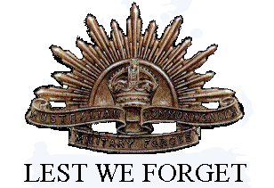
In Greensborough he is commemorated on the Greensborough and District Honour Board at the Greensborough RSL.

