Ernest Russell Paterson
Service No. 436
Rank: Trooper
Unit: 1st Australian Remount Unit
Ernest Russell Paterson was born in Colac in 1887. He was the son of Henry Francis Paterson and Sarah Sampson and the older brother of Donald Vary Paterson (Service No. 2266). His father was given as his next of kin and they were living at Prahran at the time of his enlistment on 14th September 1915.
Ernie was aged 28 years 4 months and employed as a farmer at that time.
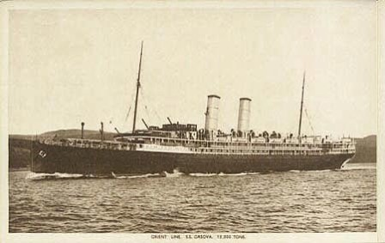
After training he embarked on HMAT Orsova A67 on 12th November 1915 and landed in Egypt in mid-December 1915.
Almost immediately he was hospitalised with mild enteritis.
Ernie served in Egypt and was hospitalised a number of times over the next few years with various diseases including Nile Fever.
He returned to Australia on the Burma on 29th August 1919. He was discharged on 23rd December 1919.
He received the 1914/15 Star, British War Medal and Victory Medal.
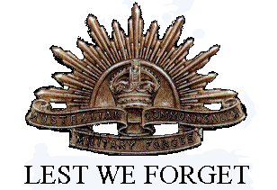
His discharge certificate states his intended post war address as Greensborough as his parents were living at “Weerona” Greensborough by then.
In Greensborough Ernest Russell Patterson is commemorated on the Greensborough and District Honour Board at the Greensborough RSL.

