Alfred Edgar Pepper
Service No. 1758
Rank: Lance Corporal.
Unit: 46th Battalion
Alfred Edgar Pepper was born in Greensborough in 1896, the son of Albert Pepper and Mary Shanhun. At the time of his enlistment the family was living at Diamond Creek. He was 19 years and 3 months old and working as a laborer when he enlisted on 10th February 1916.
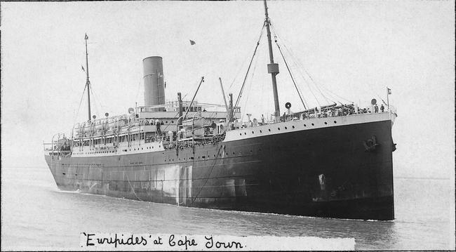
His next of kin was his father Mr. Albert Saunders Pepper of Diamond Creek. The Pepper family had 8 children.
After training he embarked on HMAT Euripedes A14 on 4th April 1916, changed ships at Alexandria on 6th June, and disembarked at Plymouth on 16th June 1916.
After completing his training in England, he was taken on strength in the 46th Battalion in France on 18th January 1917. In March 1917 he suffered from trench fever and severe frost bite and was admitted to the 3rd Field Ambulance. He rejoined his unit on 25th May 1917.
On 11th June 1917 he again hospitalised at the 76th Field Ambulance and later to the 40th Stationary Hospital at Le Havre. He rejoined his unit on 27th July 1917.
On 30th October 1917 he was promoted to Lance Corporal.
On 25th August 1918 he was wounded by gas and admitted to the 12th Field Ambulance. He was then evacuated to the Beaufort War Hospital in Bristol, England for further treatment. He did not return to the front and after treatment was returned to Australia on the Orsova on 27th February 1919.
He received his discharge on 13th April 1919.
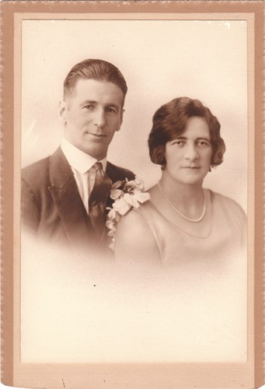
Alfred married Charlotte Brown. They had two sons. Sadly Alfred passed away in 1968 and Charlotte in 1969.
