Frederick Stanley Pepper

Service No. 3098

Rank: Lance Sergeant

Unit: 5th Engineers & 2nd Pioneers

Frederick Stanley Pepper was born in Greensborough in 1891, the son of Albert Saunders Pepper and Mary Elizabeth Shanhun. Frederick married Alice Rose Weldon in 1915. His next of kin was Mrs. Alice Pepper of Glen Creek Road, Yackandandah.

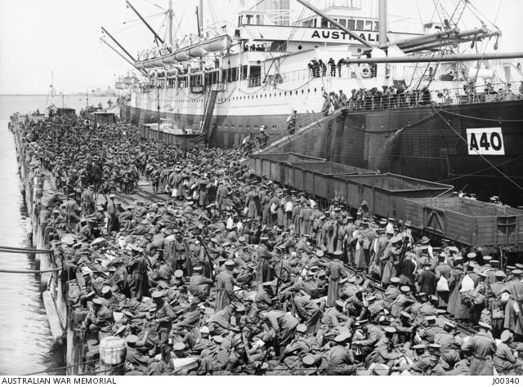He was 23 years and 10 months old and working as a Tram Conductor when he enlisted on 26th July 1915.

After training he embarked on HMAT Ceramic A40 on 23rd November 1915 and disembarked in Egypt. He was originally taken on strength in the 5th Field Company and on 6th March 1916 he was promoted to Corporal and transferred to the 2nd Pioneers battalion.

On 19th March he embarked for Marseilles and the Western Front.

Frederick was hospitalised with Trench Feet in December 1916 and sent to England for treatment. After his release from hospital he attended a number of training courses in Bayonet Fighting and Physical Training. He was promoted to the rank of Acting Sergeant and appointed to the staff of the School of Instruction in Berkshire.

On 29th July 1918 he was sent back to France and rejoined the 2nd Pioneers on 8th August 1918. He then reverted to the rank of Corporal.

He returned to Australia on the Alexandra Woermann on 1st July 1919 and was discharged on 23rd August 1919.

Frederick’s brother Alfred (Service Number 436) also served in WW1.

He received the 1914/15 Star, British War Medal and the Victory Medal.

Frederick Stanley Pepper is commemorated on the Greensborough State School Honour Board.

Sadly Frederick passed away in 1955 and Alice in 1958.