Patrick Francis Plunkett
Service No. 2422
Rank: Private
Unit: 2nd Pioneers
Patrick Francis Plunkett was born in Queenstown (St Andrews) in 1884. He was the son of Patrick Plunkett and Catherine Quarman. His father was given as his next of kin and they were living at Panton Hill at the time of his enlistment on 18th September 1915.
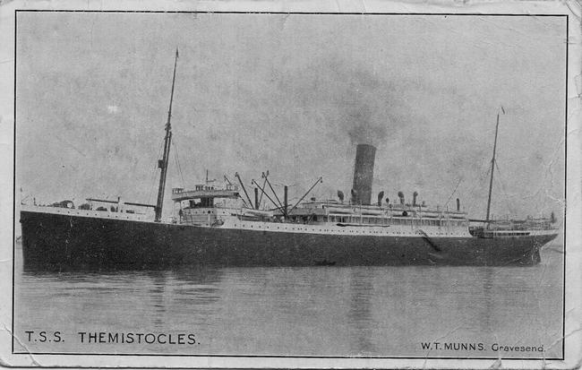
Patrick was aged 31 years 9 months and employed as a labourer at that time.
After training he embarked on HMAT Themistocles A32 on 28th July 1916 and landed at Plymouth, England on 11th September 1916.
On 28th September 1916 he was found guilty of over staying his leave and was confined for 2 days with loss of pay.
He was sent to France on 2nd November 1916 and joined his unit on 24th November.
On 11th May 1917 he received a perforated ear drum from a shell explosion and was hospitalised. On 27th May he was declared fit for duty, however before returning to the lines he got drunk and was charged accordingly. He forfeited 1 day’s pay for this offence. He rejoined his unit on 31st May 1917.
In December 1917 he was granted 2 weeks leave in England.
In March 1918 he was hospitalised with impetigo.
On 2nd April 1918 he got drunk again. This time it was taken very seriously, and Pat was the subject of a Court Martial. The charge was “When on active duty, drunkenness.” He was found guilty and sentenced to 28 days Field Punishment No. 2.
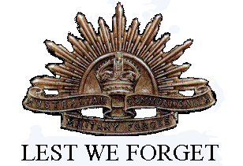
He returned to Australia on the Mahia on 17th July 1919. He was discharged on 17th October 1919.
He received the British War Medal and Victory Medal.
He passed away on the 5th November 1945.

