Bruce Alexander Pope
Service No. 564
Rank: Private
Unit: 39th Battalion and 8th Battalion
Bruce Alexander Pope was born in Carlton in 1889. He was the son of Jesse Pope. Bruce was living at Diamond Creek at the time of his enlistment on 11th March 1916 and was aged 26 years 8 months and employed as a farmer.
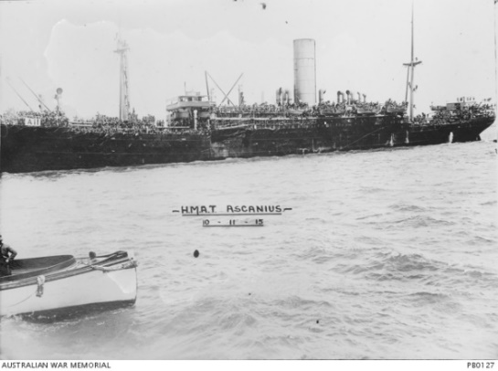
On his Attestation Paper he stated both his parents were dead and named his next of kin as Mr. Richard Thomas Page, a friend from Diamond Creek.
After training, he embarked on HMAT Ascanius A11 on 27th May 1916 and landed in England in July 1916. He was initially assigned to the 39th Battalion and was transferred to the 8th Battalion on 15th September 1916. He was also transferred to France on 15th September 1916. He joined the 8th Battalion in the field on 2nd October 1916.
He was wounded on the 7th May 1917 with a shrapnel wound to his cheek and returned to his unit on 29th July 1917.
Bruce was again wounded with a gunshot wound to his left knee on 30th September 1917 and this time was evacuated to England for care. This wound was serious enough for him to be returned to Australia for an early discharge.
He returned to Australia on the HT Euripedes A14 on 31st March 1918. He was discharged on 29th August 1918.
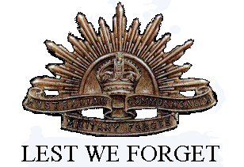
He received the British War Medal and Victory Medal.
After the war he farmed land that was on the corner of Flintoff Street (Pope Place) and Poulter Avenue Greensborough (around the area now called Pope Place). The site is now an elderly citizens village and Poulter Reserve.
He passed away in 1971 at Preston aged 82.

