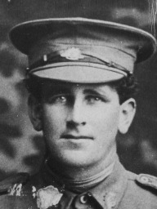
Arthur Samuel Poulter
Service No. 6836
Rank: Sapper
Unit: 1st Tunneling Company
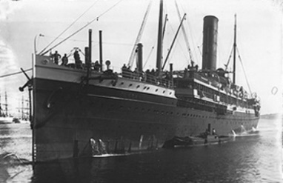
Arthur was born in Yan Yean in 1888. He was the only son of Samuel Poulter and Margaret Morrow.
Arthur was living near Yunndaga WA and working as a miner. He was aged 26 years and 1 month when he enlisted on 26th October 1916 at Blackboy Hill camp. He gave his sister Ethel as next of kin and later changed this to Mabel. Mabel’s address was given as Knox Street, Malvern East.
After initial training he embarked on HMAT Omrah A5 on 17th January 1917 and landed in England on 27th March 1917.
He served in France from 14th April 1917. During his service he was penalized 3 times for minor breaches of military law and lost pay accordingly. He was also hospitalised in England for a period in early 1918.
He returned to Australia on the Orsova on 27th February 1919. He was discharged on 29th March 1919.
Arthur received the British War Medal and the Victory Medal.
He passed away in 1974 at Parkville aged 85. Arthur Samuel Poulter was related to the Poulter family of Greensborough.
