John Adam Bush – Frederick William Bush
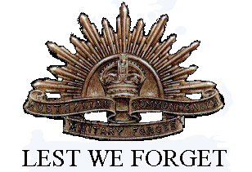Frederick William Bush Serial No. 5853 born 31st March 1892 and John Adam Bush Serial No. 2583 born 3rd February 1895 were sons of Johannes Adam Bosch and Henrietta Duck of Carron Street Moreland Coburg.
Their Father and Mother moved to Greensborough in 1899 living adjacent to the aqueduct crossing the Plenty River having bought 27½ acres from the Flintoff Family and is the reason that Frederick and his Brother John were shown as of Greensborough though both had moved away by the outbreak of WW1.

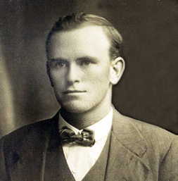Frederick William Clarence Bush
Frederick enlisted in the Royal Australian Navy 10th October 1916 at the age of 24 years and was classified as Stoker Class 2 serving for 5yrs on HMAS’s Cerberus, Brisbane and Australia until 1921 and received the British War Medal, the Victory Medal and a good conduct medal.
At the outbreak of war in August 1914, HMAS Cerberus assumed the role of Port Guard Ship for the Port of Melbourne acting as a base for the naval dock guards and small craft patrolling the harbour but in the later stages of the war, she became a store for ammunition and explosives.
The heavy cruiser HMAS Australia commissioned June 1913, during WW1 after a brief spell in the South Pacific served in the North Sea patrolling and convoy escorting whereas the light cruiser HMAS Brisbane was commissioned for service October 1916 operating in the Mediterranean, Indian Ocean and off the W.A. Coast.
, 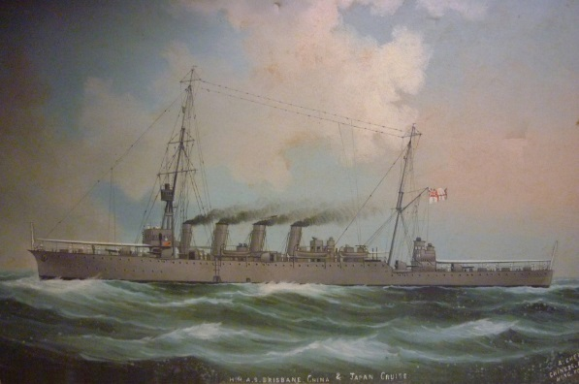 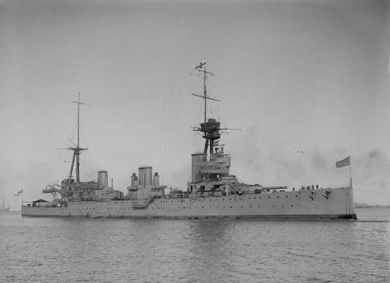
HMAS Brisbane HMAS Australia
Frederick is described as being 5ft 3½inch tall with light brown hair with blue eyes and fair complexion having a tattoo of a dog smoking a pipe on his right forearm.
He married Kathleen Eileen Jordon 20th September 1918 however they were divorced in March 1922.
He returned to Australia in 1919 living in North Carlton and referred to in the electoral roll of 1925 as a mechanic then moved to North Essendon where he was referred to as a driver prior to being shown to be living in Bundoora from 1937 to 1949 (no address) as a gardener.
He worked as a taxi driver for a number years possibly Yellow Cabs.
He eventually moving to Browns Lane Plenty where he continued to drive a taxi as well as keep livestock on his farm where he died in August 1952 aged 67 years.
Frederick William Clarence Bush is commemorated for his war service on the Greensborough District Honour Board at the Greensborough RSL and on the Greensborough Primary School Honour Board.

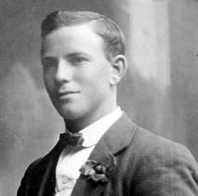John Adam Bush
John enlisted 12th September 1914 age shown as 22 years 7 months however his birth date of
3rd February 1895 indicates him being 19 years 7 months enlisting and embarking from Sydney on the Argyllshire suggesting his parents were not enthusiastic about his enlistment.

He is recorded as serving as a driver and stretcher bearer serving with First Field Artillery Brigade then volunteered for the 3rd Battalion at Lone Pine followed by service in France with 150 Battery and 20th Army Service Corps.

He suffered several bouts of sickness including pleurisy whilst in Egypt spending time in hospital as well as in England; it was whilst in England he met his future wife Edith Eleonor Hayward who could have been responsible for him being AWL on a couple of occasions however they were married 20th October 1916 with the Army’s blessing.

John arrived back in Australia 8th February 1919 on board the HMAT Miltiades with his wife Eda and one year old son Frederick William Clarence Bush.

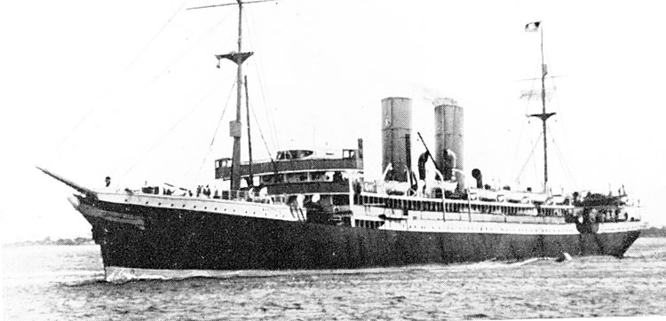
HMAT Miltiades

Like his brother Fred, John also took to Taxi driving working for Globe Motor and Taxi Co. and like other taxi drivers came across incidents that they would have preferred not to have encountered and on occasions was required as a witness to a crime scene.

One case involved the Police apprehending a man for being drunk whilst in charge of a vehicle however two witnesses including John Bush testified that the person appeared to be drunk but was in fact unwell and did not smell of alcohol. The case was dismissed.

On another occasion when John Bush had a full complement of passengers he was hailed by a man standing in the road who upon being told that he could not take him as his taxi was full the man abused him.

This man is believed to be Norman List who had just shot five people in Melbourne’s Botanical Gardens four of whom died. Norman List took his own life shortly after.

It is as well that Fred and John were serving in the war because their father John Adam Bush (formally Johannes Adam Bosch a naturalized German of Greensborough) on 22nd August 1915 addressed a crowd at the Bijou Theatre in Russell Street saying that the population had been lied to and the poor fools going to war had to have sense knocked into them and that the troops on both sides should all go home and the war would be over.

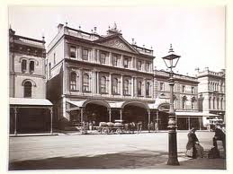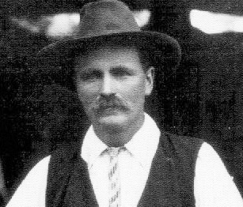

Detectives were present at the gathering because it was organised by the Australian Communist Party and he was committed to trial on the grounds he was prejudicing recruitment which he defended by saying that people should understand that he had been born in Germany and therefore had some allegiance to that country but that he had two sons fighting for the Empire and his daughter had volunteered to become a nurse but had been rejected as she had no training.

He was found guilty and sentenced to three months imprisonment however due to his son’s involvement in the war the sentence was suspended on his finding a surety of £50 that he would refrain from making any further such statements.

