George Henry Poulter
Service No. 96
Rank: Lance Corporal
Unit: 2nd Field Company Royal Australian Engineers
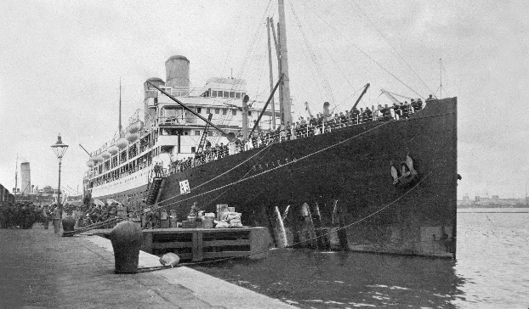
George Henry Poulter was born in Carlton in 1884. He was the son of John Poulter and Violet Staines of 79 Baker St, Richmond. George was living in Richmond working as an Engine Driver when he enlisted as a Sapper on 20th August 1914, aged 30 years. He gave his father John as next of kin.
After training he embarked on HMAT Orvietto A3 on 21st October 1914 and landed in Egypt in December 1914. On 5th April 1915 he joined the Middle East Force at Alexandria.
During June 1915 he suffered from dysentery at Gallipoli and later conjunctivitis which eventually resulted in his evacuation to Mudros. This medical problem resulted in his transfer to Malta and eventually to Weymouth England and Cardiff Wales.
On 17th June 1916, he was finally redeployed to 13th Field Company Royal Australian Engineers in France. On 10th November 1917 he was promoted to Lance Corporal.
In August 1918 he was suffering from debility and admitted to hospital in Bristol.
On 30th September 1918 he was granted permission to marry Elizabeth Bathgate in Edinburgh.
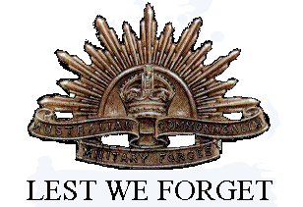
He returned to Australia on the Port Lyttleton D30 on 21st December 1918. He was discharged on 24th February 1919. On 25th January he had applied for free passage to Australia for his wife.
George Henry Poulter received the 1914/15 Star, British War Medal and the Victory Medal.
He passed away on 2nd August 1948.
George Henry Poulter was related to the Poulter family of Greensborough.

