Herbert Charles Poulter
Service No. 5650
Rank: Private
Unit: 24th Battalion
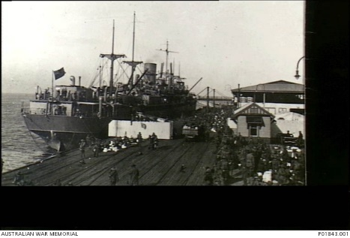
Herbert was born in Richmond in 1892. He was the son of John Poulter and Violet Staines of 79 Baker St, Richmond. Herbert was living in Richmond working as a Fellmonger (skins worker) when he enlisted on 29th March 1916, aged 24 years, 1 month. He gave his father John as next of kin.
After initial training he embarked on HMAT Shropshire A9 on 25st September 1916 and landed in England on 11th November 1916. On 24th January 1917 he commenced service in France.

On 14th March 1917, he was wounded in action with gunshot wounds to his thigh and right foot. These wounds were serious enough to prevent his return to his unit. In October 1917 he was repatriated to Australia on the Port Lyttleton and discharged on 1st February 1918.
He received the British War Medal and the Victory Medal.
He passed away in 1967 aged 77.
Herbert Charles Poulter was related to the Poulter family of Greensborough.
