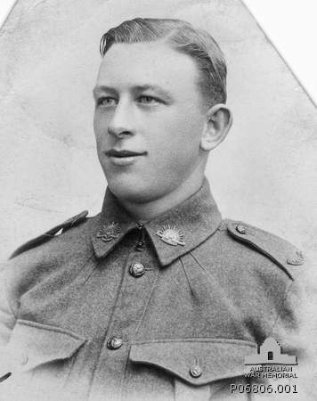
James William Poulter
Service No. 5078
Rank: Private
Unit: 22nd Battalion
James William Poulter was born in 1899 in Greensborough, the son of William Haylock Poulter and Mary Alice Dalrymple. At the time of his enlistment the family was living at “Bonnie Vale” in Poulter Avenue Greensborough. He was 18 years old and working as a driver when he enlisted on 14th February 1916.
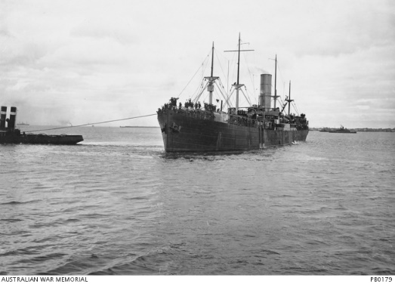
After training James travelled on HMAT Ayrshire A33 and landed in England on 2nd September 1916; on 21st September he was admitted to hospital suffering tonsillitis with several further admissions that year. He was taken on strength in March 1917 and saw active service in France.
James suffered a gunshot wound to his right shoulder on 18th September 1917 and was evacuated to England for treatment. By February 1918, James had been sent to Longbridge Deverill and Sutton Veny, a training base and convalescent hospital; March and April of that year saw James at Fovant Camp. These camps are all situated on Salisbury Plain.
James rejoined his battalion in June 1918 from the Training Battalion. He was again wounded in action - this time gassed - in July 1918. He was again hospitalised and treated for two months. He rejoined his unit on 26th September 1918.
James William Poulter was killed in action 4th October 1918 at Beaurevoir, France. He was 19 years old. He is buried at Prospect Hill Cemetery Gouy, France
He was awarded the British War Medal, Victory Medal and Memorial Plaque.
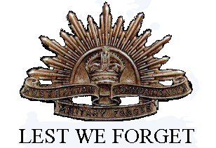
James William Poulter is commemorated in Greensborough on the Fallen Soldier’s Memorial, Greensborough Primary School Honour Board and the Greensborough and District Honour Board at the Greensborough RSL. James had a street named in his honour in Greensborough. What is now Jessop Street was formerly James Street and before that Chapel Street.

