Percy John Poulter
Service No. 237
Rank: Private
Unit: 6th Battalion
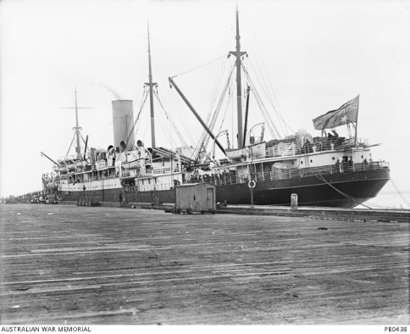
Percy John Poulter was born in Richmond in 1891. He was the son of John Poulter and Violet Staines of 79 Baker Street, Richmond. Percy was living in Richmond working as a tramways employee when he enlisted on 21st August 1914, aged 23 years, 5 months. He gave his father John as next of kin.
After initial training he embarked on HMAT Hororata A20 on 19th October 1914 and landed in Egypt. He served at Gallipoli and spent time in the 2nd Australian Hospital in Cairo. When he was released from hospital in early 1916, the Gallipoli campaign had concluded and he was sent to Europe to rejoin his unit, which he did on 11th March 1916.
On 15th October 1916 he was admitted to the London War Hospital with cellulitis, he was released back to his unit on 28th June 1917.
On 3rd October 1917 he received a gunshot wound to his right thigh and was again hospitalised and on 6th February 1918 embarked for Australia on the Hospital Transport Euripides A14 and discharged on 15th May 1918.
He received the 1914/15 Star, British War Medal and the Victory Medal.
On 18th September 1916 Percy was awarded the Cross of St George 4th Class. This was a Russian Decoration awarded by the Czar of Russia.
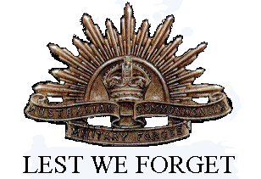
He passed away at Ivanhoe in 1976 aged 85.
Percy John Poulter was related to the Poulter family of Greensborough.

